
LJ INSTITUTE OF COMPUTER APPLICATION
&
Master of Computer Application Sem 3
SOFTWARE PROJECT :-1

PROJECT REPORN ON
HOSPITAL MANAGEMENT SYSTEM

Under the Guidance of
Prof. AJAY CHAUHAN

GROUP NUMBER:-63
SUBMITTED BY:-

Div Roll No. | Enrollment No. | Name
D45 | 25004401110226 | Lakshit Suthar
D23 | 25004401110192 | Nirmeet Makwana
D48 | 25004401110211 | Princi Trapasiya

TABLE OF CONTENTS

Contents

TABLE OF CONTENTS 2
1. PROBLEM DEFINITION 3
2. OBJECTIVES 3
3. CORE COMPONENTS / MODULES 3
4. PROJECT PROFILE 5
5. NEED OF THE SYSTEM 6
6. SCOPE OF THE PROJECT 6
7. ADVANTAGES OF HOSPITAL MANAGEMENT SYSTEM 8
8. LIMITATIONS OF HOSPITAL MANAGEMENT SYSTEM 9
9. PROPOSED TIMELINE CHART 9
10. TARGETED USERS 10
11. REQUIREMENT DETERMINATION AND ANALYSIS 11
12. REQUIREMENT DETERMINATION 11
13. REQUIREMENT SPECIFICATION 12
14. SYSTEM DESIGN 13
14.1 High-Level Architecture 13
14.2 Main System Modules 13
14.3 Main Database Entities 13
15. USE CASE DIAGRAM 14
Use Case Explanation 14
16.Data Dictionary 15
17.Coding Standards 19
18.USER INTERFACE DESIGN 24

1. PROBLEM DEFINITION
Hospitals handle a large amount of information every day, including patient registration, doctor schedules, appointments, medical records, prescriptions, billing, and reports. When these activities are managed manually or through separate systems, staff may spend more time searching, entering, and updating information. This can create delays, duplicate work, paperwork, and difficulty in maintaining accurate records.
The proposed Hospital Management System is a web-based system designed to reduce time consumption and simplify hospital operations. The system will provide separate secure logins for Doctor, Super Admin, Patient, and Receptionist. Each user will get access to functions according to their role. The system will centralize patient information, appointments, doctor information, prescriptions, billing, and reports so that required information can be accessed quickly.

2. OBJECTIVES
The main objective of the Hospital Management System is to digitize and streamline hospital activities so that routine work can be completed in less time.
- To provide a centralized system for managing hospital information.
- To provide separate and secure login access for Doctor, Super Admin, Patient, and Receptionist.
- To reduce the time required for patient registration and appointment management.
- To allow receptionists to quickly manage patients and appointments.
- To allow doctors to view patient records and manage prescriptions efficiently.
- To allow patients to view their appointments and relevant medical information.
- To allow the Super Admin to manage users, doctors, patients, and overall hospital records.
- To reduce paperwork, duplicate data entry, and manual searching.
- To improve the accuracy, availability, and security of hospital information.
- To generate useful reports and dashboards for hospital administration.
- To create a billing record automatically when an appointment is booked, including an extra fee if the patient does not show up.
- To let the Super Admin turn two-step OTP login verification on or off for the whole system as needed.

3. CORE COMPONENTS / MODULES
The Hospital Management System (HMS) is divided into different modules based on user roles and system functionality. Each module performs specific operations and interacts with the centralized database according to the authorization provided to the user.SS
1. Super Admin Module
The Super Admin controls the overall Hospital Management System. The admin can manage doctors, receptionists, patients, user accounts, appointments, billing records, hospital information, security settings, and system reports.
2. Doctor Module
The Doctor Module allows doctors to manage their profiles, view assigned appointments, access patient information, add diagnoses, create prescriptions, update medical notes, and manage their availability.
3. Patient Module
The Patient Module allows patients to manage their profiles, view doctors, book appointments, check appointment history and status, view prescriptions and medical information, access billing history, and receive notifications.
4. Receptionist Module
The Receptionist Module handles front-desk operations. Receptionists can register patients, manage basic patient information, book and manage appointments, check doctor availability, and handle front-desk billing payments.
5. Appointment Management Module
This module manages the complete appointment process, including appointment booking, doctor availability, scheduling, appointment status, appointment history, and related notifications.
6. Patient Management Module
This module stores and manages patient information such as personal details, contact information, profiles, appointment history, visit history, and authorized medical records.
7. Prescription and Medical Record Module
This module manages patient diagnosis, prescriptions, medicines, treatment details, and medical notes. Doctors can create and update medical information, while patients can view the information made available to them.
8. Billing Module
The Billing Module automatically creates bills for appointments, manages appointment charges and no-show fees, tracks outstanding bills and payment status, and allows authorized staff to record front-desk payments.
9. Database and Data Management Module
This module stores and manages system data, including users, patients, doctors, receptionists, appointments, prescriptions, billing records, and notifications. It also maintains proper relationships and data consistency.
10. Security & Authentication Module
This module provides secure login, role-based access control, session management, and logout functionality. It also supports optional two-step email OTP verification, which can be enabled or disabled by the Super Admin.

Overall System Flow
The general workflow of the Hospital Management System is:
User Login → Credential Verification → OTP Verification (if enabled) → Role Verification → Role-Based Dashboard → Perform Authorized Task → Database Update/Retrieval → Display Result/Report
Role-Based Flow
Super Admin:
Login → OTP Verification (if enabled) → Admin Dashboard → Manage Doctors / Receptionists / Patients / Users / Billing / Security Settings → Database Update → Result
Doctor:
Login → OTP Verification (if enabled) → Doctor Dashboard → View Appointments → Access Authorized Patient Information → Add Diagnosis / Prescription / Treatment Information → Database Update → Result
Patient:
Login → OTP Verification (if enabled) → Patient Dashboard → View Doctors / Book Appointment / View Appointments / Prescriptions / Bills → Database Retrieval or Update → Result
Receptionist:
Login → OTP Verification (if enabled) → Receptionist Dashboard → Register Patient / Check Doctor Availability / Manage Appointment / Handle Billing → Database Update → Result

4. PROJECT PROFILE
Project Detail | Description
Project Title | Hospital Management System
Project Type | Web-Based Hospital Management Application
Main Purpose | Reduce time consumption and simplify hospital operations
User Roles | Super Admin, Doctor, Patient, Receptionist
Programming Language | Python
Web Framework | Django / Python Web Framework
Frontend | HTML, CSS, JavaScript, Bootstrap
Database | MySQL / SQLite
Development Environment | Visual Studio Code
Expected Outcome | A centralized, role-based hospital system that makes common hospital tasks faster, organized, and easier to manage.

5. NEED OF THE SYSTEM
A hospital requires fast and accurate access to information because doctors, receptionists, patients, and administrators perform different activities throughout the day. Manual processes can increase waiting time and make it difficult to locate records quickly.
- To reduce patient registration and appointment processing time.
- To reduce paperwork and repetitive manual data entry.
- To provide quick access to patient and appointment information.
- To provide role-based access so each user sees only the functions required for their work.
- To reduce communication gaps between reception, doctors, patients, and administration.
- To maintain centralized and organized hospital records.
- To reduce duplicate records and improve data accuracy.
- To make routine hospital activities easier and faster.
Key Differentiating Features:
- Four role-based logins: Super Admin, Doctor, Patient, and Receptionist.
- Centralized hospital database.
- Quick patient registration and appointment handling.
- Doctor dashboard for appointments and medical records.
- Patient dashboard for appointments and available medical information.
- Receptionist dashboard for front-desk operations.
- Super Admin dashboard for overall management and reports.
- Reduced time consumption through digital workflows.

6. SCOPE OF THE PROJECT
The scope of the Hospital Management System is to provide a centralized web-based platform for managing common hospital operations efficiently. The major areas covered by the system are:
1. User Authentication and Role Management
- Separate login for Super Admin, Doctor, Patient, and Receptionist.
- Role-based access to system features and dashboards.
- Secure session management and logout.
- Optional two-step email OTP verification controlled by the Super Admin.
2. Patient Registration
- Registration of new patients by the Receptionist.
- Storage of basic personal and contact information.
- Updating authorized patient details.
- Retrieval of registered patient information when required.
3. Doctor Management
- Add and manage doctor accounts and profiles.
- Maintain specialization and contact information.
- Manage doctor availability and schedules.
- Update doctor information when required.
4. Appointment Management
- Book appointments with available doctors.
- Check doctor availability before appointment booking.
- Update and track appointment status.
- Maintain current and previous appointment records.
5. Doctor Dashboard
- View assigned and upcoming appointments.
- Access authorized patient information.
- View patient appointment history.
- Manage availability and treatment-related activities.
6. Patient Dashboard
- View and update permitted profile information.
- View available doctors and book appointments.
- Check appointment history and status.
- View prescriptions, medical information, and billing details.
7. Medical Records
- Store patient diagnosis and treatment information.
- Maintain medical notes entered by doctors.
- Retrieve previous medical information when required.
- Restrict medical record access based on user roles.
8. Prescription Management
- Create prescriptions for patients.
- Add prescribed medicines and instructions.
- Maintain previous prescription records.
- Allow patients to view their prescriptions.
9. Billing
- Automatically generate a bill when an appointment is booked.
- Maintain appointment charges and billing records.
- Add a no-show fee when a confirmed appointment is missed.
- Allow authorized staff to view outstanding bills and mark payments as paid.
10. Reports
- Generate reports related to patients and doctors.
- Generate appointment-related reports.
- Generate billing and payment reports.
- Allow the Super Admin to access reports for administrative purposes.
11. Future Enhancement
The system can be further enhanced with:
- Online payment gateway integration.
- SMS and email notifications.
- Laboratory and test report management.
- Pharmacy and medicine inventory management.
- Mobile application support.
- Advanced analytics and reporting features.

7. ADVANTAGES OF HOSPITAL MANAGEMENT SYSTEM
- Time Saving: Digital processes reduce the time required for patient registration, appointment management, billing, and record searching.
- Centralized Data: Patient, doctor, appointment, prescription, and billing information is maintained in one organized system.
- Role-Based Access: Super Admin, Doctor, Patient, and Receptionist have access to features according to their roles.
- Reduced Paperwork: Electronic records reduce the need for manual files, registers, and forms.
- Quick Patient Search: Authorized users can quickly search and access required patient information.
- Better Appointment Management: Doctor availability, appointment booking, and appointment status can be managed efficiently.
- Improved Accuracy: Digital records help reduce duplicate entries and common manual errors.
- Better Information Sharing: Authorized users can access updated information according to their roles.
- Easy Reporting: The Super Admin can generate and review reports related to patients, doctors, appointments, and billing.
- Future Expandability: Additional modules and features can be added as hospital requirements grow.

8. LIMITATIONS OF HOSPITAL MANAGEMENT SYSTEM
- Network Dependency: The system may become temporarily unavailable if the network or server is down.
- Initial Setup: Development, configuration, and deployment require time and resources.
- Training Requirement: Hospital staff may require basic training to use the system properly.
- Data Security: Patient and medical information must be properly protected from unauthorized access.
- System Maintenance: Regular software, database, and security maintenance is required.
- Limited Initial Scope: The current version does not include advanced modules such as laboratory, pharmacy, ambulance, insurance management, or online payment.
- Hardware Dependency: Computers and suitable server resources are required for reliable system operation.

9. PROPOSED TIMELINE CHART

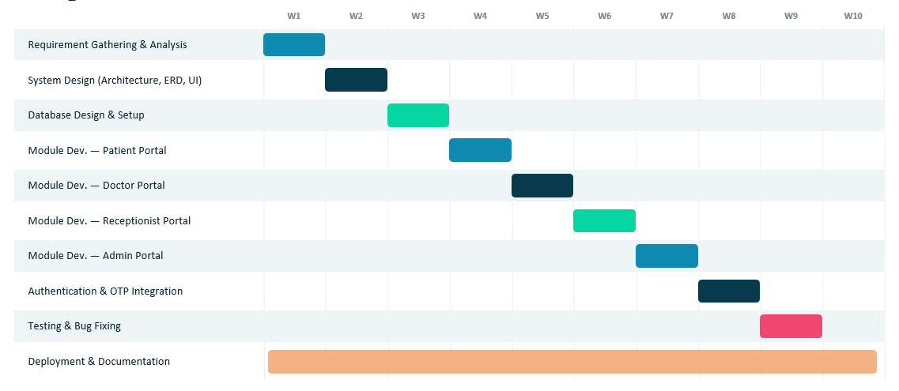

10. TARGETED USERS
1. Super Admin
Manages the overall system, users, doctors, hospital information, billing records, reports, and system activities, including switching two-step OTP login on or off.
2. Doctors
Use the system to manage appointments, view authorized patient information, record diagnoses, and create prescriptions.
3. Patients
Use the system to view appointments, doctor information, prescriptions, and available personal medical information.
4. Receptionists
Manage patient registration, appointments, doctor availability, and authorized front-desk activities.
5. Hospital Management
Uses reports and dashboards to monitor hospital operations and make administrative decisions.

11. REQUIREMENT DETERMINATION AND ANALYSIS
Requirement determination identifies what the hospital needs from the proposed system. The main focus is to reduce time-consuming manual processes and provide a single platform for role-based hospital management.
- Study the current hospital registration and appointment process.
- Identify delays caused by manual record searching and repeated data entry.
- Identify the information required by doctors, patients, receptionists, and administrators.
- Determine the data that must be stored in the database.
- Define role-based permissions and security requirements.
- Identify reports and dashboards required by hospital management.
- Analyze the system for usability, performance, reliability, and scalability.

12. REQUIREMENT DETERMINATION
The requirements are divided into functional and non-functional requirements.
Functional Requirements
- User registration and secure login.
- Role-based dashboard for Super Admin, Doctor, Patient, and Receptionist.
- Patient registration and profile management.
- Doctor profile and availability management.
- Appointment booking, updating, cancellation, and status tracking.
- Doctor access to authorized patient records.
- Prescription creation and management.
- Patient access to appointments and authorized medical information.
- Billing record management, including automatic bill creation at booking and no-show fee billing.
- Reports and dashboard information.
- Secure logout and session management.
- Super Admin control to enable or disable two-step OTP verification for all logins.
Non-Functional Requirements
- Usability: The interface should be simple and easy to understand.
- Performance: Common operations should respond quickly to reduce waiting time.
- Security: User accounts and medical information must be protected from unauthorized access.
- Reliability: The system should operate consistently and handle valid requests correctly.
- Scalability: The system should support future modules and increasing data.
- Maintainability: The code and database should be organized for easy updates.
- Compatibility: The web application should work on commonly used modern browsers.

13. REQUIREMENT SPECIFICATION
1. Hardware Requirements
- Computer/Laptop with a modern processor.
- Minimum 4 GB RAM.
- Minimum 5 GB available storage for project files and database.
- Display/monitor.
- Stable local network or Internet connection as required by deployment.
2. Software Requirements
- Operating System: Windows / Linux / macOS.
- Programming Language: Python.
- Web Framework: Django.
- Frontend: HTML, CSS, JavaScript, Bootstrap.
- Database: MySQL / SQLite.
- Development Environment: Visual Studio Code.
- Web Browser: Google Chrome, Microsoft Edge, or another modern browser.
- Version Control: Git/GitHub (optional).
3. Role-Based Functional Specification
Super Admin
The system shall provide Super Admin login. The Super Admin shall be able to manage doctors, receptionists, patients, user accounts, hospital information, billing records, and authorized system records, and shall be able to enable or disable two-step OTP verification for all logins.
Doctor
The system shall provide Doctor login. Doctors shall be able to view assigned appointments, access authorized patient records, add diagnosis/notes, and create prescriptions.
Patient
The system shall provide Patient login. Patients shall be able to view their profile, appointments, doctor information, prescriptions, and authorized medical information.
Receptionist
The system shall provide Receptionist login. Receptionists shall be able to register patients, manage appointments, check doctor availability, update authorized patient details, mark a missed appointment as a no-show with an automatic fee, and handle permitted billing operations.

14. SYSTEM DESIGN
The proposed system follows a role-based web application architecture. Users access the application through a browser. After login, the system identifies the user's role and redirects the user to the appropriate dashboard. The application layer processes requests and communicates with the database to store or retrieve information.

14.1 High-Level Architecture
User → Web Browser → Django Application → Authentication & Role Management → Business Modules → MySQL/SQLite Database

14.2 Main System Modules
- Authentication and Authorization
- Security Settings (Two-Step OTP Toggle)
- Super Admin Dashboard
- Doctor Dashboard
- Patient Dashboard
- Receptionist Dashboard
- Patient Management
- Doctor Management
- Appointment Management
- Medical Record Management
- Prescription Management
- Billing Management
- Reports and Dashboard

14.3 Main Database Entities
- User
- Doctor
- Patient
- Receptionist
- Appointment
- Medical Record
- Prescription
- Bill
- Department (if required)
- Hospital Settings / System Information (e.g., two-step OTP toggle)

15. USE CASE DIAGRAM
The Use Case Diagram represents how the four main actors interact with the Hospital Management System. The actors are Super Admin, Doctor, Patient, and Receptionist. Each actor receives access to functions according to their role.
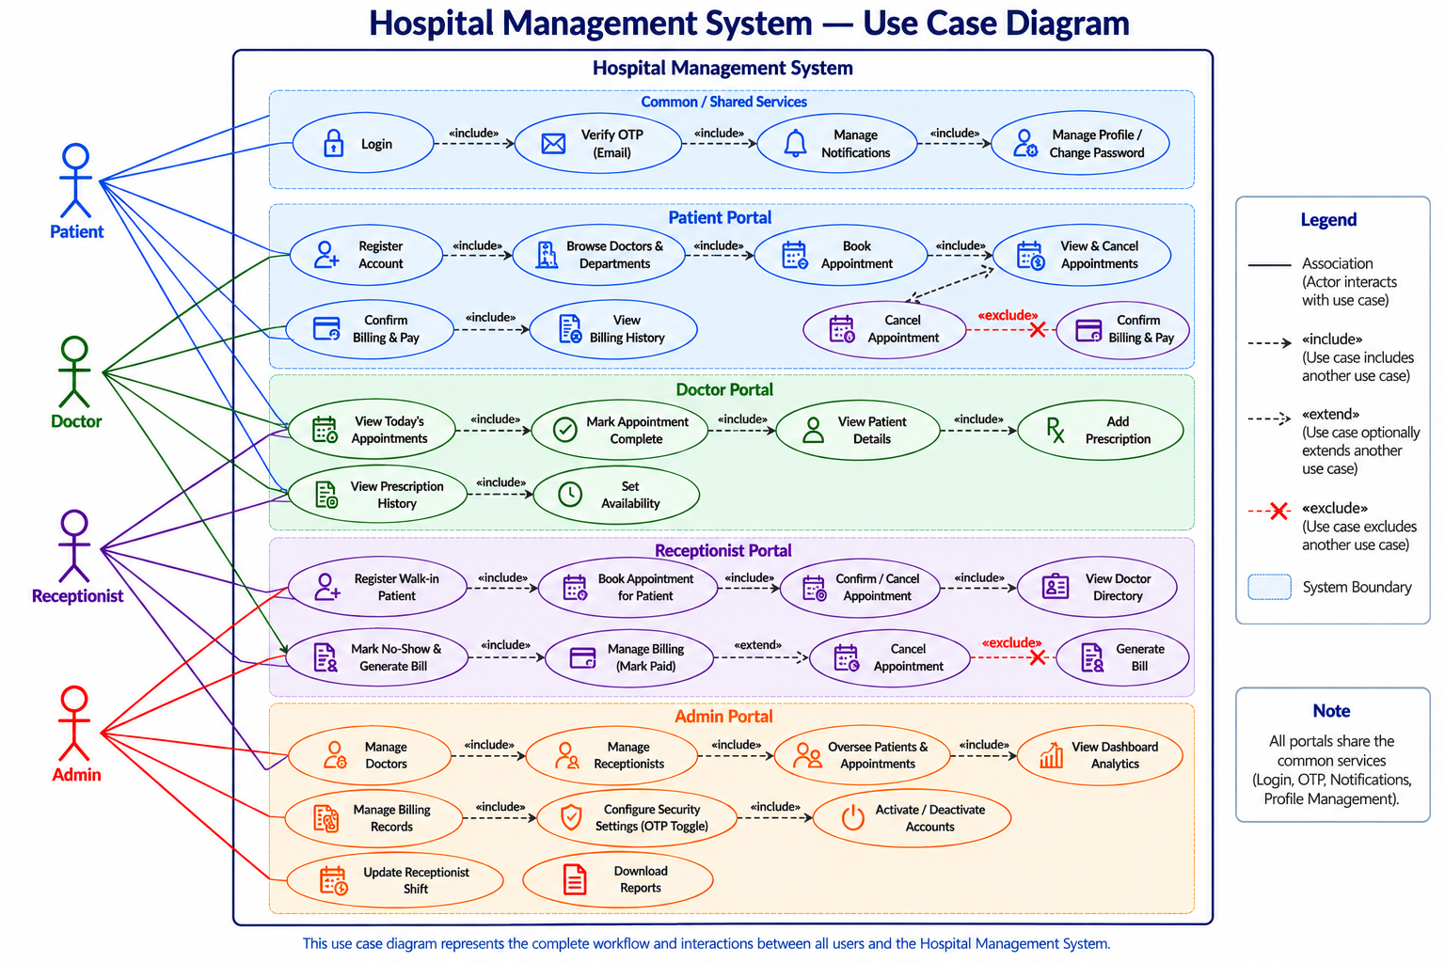
Figure 1: Use Case Diagram – Hospital Management System

Use Case Explanation
1. Super Admin
- Login securely to the system.
- Manage system users and their roles.
- Add, update, and manage doctors and receptionists.
- Manage system records and configurations.
- Manage and monitor billing activities.
- Enable or disable two-step OTP verification.
- View system reports and dashboard statistics.

2. Doctor
- Login securely to the system.
- View and manage appointments.
- View authorized patient information and medical records.
- Create and manage patient prescriptions.
- Add and update relevant patient medical information.

3. Patient
- Login securely to the system.
- View upcoming and previous appointments.
- View doctor information and details.
- View authorized prescriptions and medical records.
- View billing/payment information where permitted.

4. Receptionist
- Login securely to the system.
- Register and manage patient information.
- Book, update, and manage appointments.
- Check doctor availability and schedules.
- Mark appointments as No-Show when required.
- Perform permitted billing and payment-related activities.

16.Data Dictionary
A Data Dictionary provides a structured description of the data stored and managed by the Hospital Management System. It defines the database tables, their fields, data types, sizes, constraints, and the purpose of each field.

The Hospital Management System uses a relational database to store information related to users, patients, doctors, receptionists, appointments, billing, notifications, prescriptions, doctor availability, and other system activities.

The following Data Dictionary represents the database structure used in the current implementation of the Hospital Management System. For each model, it specifies the field name, data type, size, key or constraint, and description.

The created_at fields are used to record when a record is initially created, while updated_at fields are used in applicable models to automatically record when a record was last modified.

16.1 User (accounts.User)
Field Name | Data Type | Size | Key / Constraint | Description
id | BigAutoField | - | PK, Auto | Primary key generated by Django.
password | CharField | 128 | Required | Hashed user password.
last_login | DateTimeField | - | Null allowed | Date/time of the user's last login.
is_superuser | BooleanField | - | Default False | Indicates whether the user has all permissions.
username | CharField | 150 | Unique | Django username; retained for superuser creation.
first_name | CharField | 150 | Blank allowed | User's first name.
last_name | CharField | 150 | Blank allowed | User's last name.
email | EmailField | 254 | Unique | Primary login identifier for the system.
is_staff | BooleanField | - | Default False | Allows access to Django admin when enabled.
is_active | BooleanField | - | Default True | Indicates whether the account is active.
date_joined | DateTimeField | - | Default current time | Date/time the user account was created.
role | CharField | 20 | Default patient; Choices | Role: admin, doctor, receptionist, or patient.
otp_code | CharField | 6 | Null/Blank | Current one-time password code, when generated.
otp_created_at | DateTimeField | - | Null/Blank | Time at which the current OTP was generated.
otp_attempts | PositiveSmallIntegerField | - | Default 0 | Number of consecutive incorrect OTP attempts.
otp_locked_until | DateTimeField | - | Null/Blank | Temporary OTP lockout expiry time.
groups | ManyToManyField | - | Optional | Django authorization groups assigned to the user.
user_permissions | ManyToManyField | - | Optional | Django permissions assigned directly to the user.

16.2 Patient (patient.Patient)
Field Name | Data Type | Size | Key / Constraint | Description
id | BigAutoField | - | PK, Auto | Primary key.
user_id | OneToOneField | - | FK → User, Unique, Cascade | Links the patient profile to its login account.
patient_id | CharField | 20 | Unique, Auto-generated | Human-readable patient number.
profile_image | ImageField | - | Null/Blank | Patient profile image.
registered_by_id | ForeignKey | - | FK → Receptionist, SET_NULL | Receptionist who registered a walk-in patient.
phone | CharField | 15 | Blank allowed | Patient contact number.
date_of_birth | DateField | - | Null/Blank | Patient date of birth.
gender | CharField | 10 | Blank; Choices | Male, Female, or Other.
blood_group | CharField | 5 | Blank; Choices | Patient blood group.
address | TextField | - | Blank allowed | Patient residential address.
city | CharField | 100 | Blank allowed | City of residence.
state | CharField | 100 | Blank allowed | State of residence.
country | CharField | 100 | Blank allowed | Country of residence.
pincode | CharField | 10 | Blank allowed | Postal/PIN code.
emergency_contact_name | CharField | 100 | Blank allowed | Emergency contact person's name.
emergency_contact_number | CharField | 15 | Blank allowed | Emergency contact phone number.
allergies | TextField | - | Blank allowed | Known patient allergies.
medical_history | TextField | - | Blank allowed | Patient medical history notes.
created_at | DateTimeField | - | Auto now add; Indexed | Date/time patient record was created.
updated_at | DateTimeField | - | Auto now | Date/time patient profile was last updated.

16.3 Appointment (patient.Appointment)
Field Name | Data Type | Size | Key / Constraint | Description
id | BigAutoField | - | PK, Auto | Primary key.
patient_id | ForeignKey | - | FK → Patient, Cascade | Patient who owns the appointment.
doctor_id | ForeignKey | - | FK → Doctor, Cascade | Doctor assigned to the appointment.
appointment_date | DateField | - | Indexed | Scheduled appointment date.
time_slot | CharField | 20 | Required | Selected appointment time label.
visit_type | CharField | 20 | Default new; Choices | New visit or follow-up visit.
reason | TextField | - | Required | Reason for the appointment.
status | CharField | 20 | Default pending; Indexed | Appointment status.
created_at | DateTimeField | - | Auto now add | Date/time appointment was created.
updated_at | DateTimeField | - | Auto now | Date/time appointment record was last updated.
department | CharField | 30 | Default general; Choices | Department selected for the appointment.
reminder_sent | BooleanField | - | Default False | Tracks whether the reminder was already sent.

16.4 Billing (patient.Billing)
Field Name | Data Type | Size | Key / Constraint | Description
id | BigAutoField | - | PK, Auto | Primary key.
appointment_id | ForeignKey | - | FK → Appointment, Cascade | Appointment associated with the charge.
patient_id | ForeignKey | - | FK → Patient, Cascade | Patient responsible for the bill.
bill_type | CharField | 20 | Default consultation; Choices | Consultation fee or no-show fee.
amount | DecimalField | 8,2 | Default 0 | Amount charged.
status | CharField | 10 | Default pending; Indexed | pending, paid, or waived.
created_at | DateTimeField | - | Auto now add | Date/time bill was created.
updated_at | DateTimeField | - | Auto now | Date/time billing record was last updated.
paid_at | DateTimeField | - | Null/Blank | Date/time payment was recorded.

16.5 ContactMessage (patient.ContactMessage)
Field Name | Data Type | Size | Key / Constraint | Description
id | BigAutoField | - | PK, Auto | Primary key.
full_name | CharField | 150 | Required | Name submitted through the contact form.
email | EmailField | 254 | Required | Contact email address.
phone | CharField | 15 | Required | Contact phone number.
subject | CharField | 50 | Required | Contact message subject.
message | TextField | - | Required | Contact message body.
created_at | DateTimeField | - | Auto now add | Date/time the message was submitted.

16.6 Notification (patient.Notification)
Field Name | Data Type | Size | Key / Constraint | Description
id | BigAutoField | - | PK, Auto | Primary key.
user_id | ForeignKey | - | FK → User, Cascade | User who receives the notification.
notification_type | CharField | 30 | Default general; Choices | confirmed, reminder, cancelled, or general.
message | CharField | 255 | Required | Notification text.
is_read | BooleanField | - | Default False | Indicates whether the notification has been read.
created_at | DateTimeField | - | Auto now add | Date/time notification was created.

16.7 Doctor (doctor.Doctor)
Field Name | Data Type | Size | Key / Constraint | Description
id | BigAutoField | - | PK, Auto | Primary key.
user_id | OneToOneField | - | FK → User, Unique, Cascade | Links doctor profile to its login account.
department | CharField | 30 | Choices | Doctor's hospital department.
specialization | CharField | 100 | Blank allowed | Doctor's specialization.
phone_number | CharField | 20 | Blank allowed | Doctor contact number.
qualification | CharField | 150 | Blank allowed | Professional/academic qualification.
experience_years | PositiveIntegerField | - | Default 0 | Years of professional experience.
consultation_fee | PositiveIntegerField | - | Default 0 | Fee charged per consultation.
bio | TextField | - | Blank allowed | Doctor biography/profile information.
profile_picture | ImageField | - | Null/Blank | Doctor profile image.
license_number | CharField | 50 | Blank allowed | Medical license/registration number.
registered_since | PositiveIntegerField | - | Null/Blank | Year from which the doctor has been registered.
slot_duration | PositiveIntegerField | - | Default 30 | Appointment duration in minutes.
buffer_time | PositiveIntegerField | - | Default 5 | Gap between appointment slots in minutes.
max_per_day | PositiveIntegerField | - | Null/Blank | Optional maximum number of appointment slots per day.

16.8 DoctorAvailability (doctor.DoctorAvailability)
Field Name | Data Type | Size | Key / Constraint | Description
id | BigAutoField | - | PK, Auto | Primary key.
doctor_id | ForeignKey | - | FK → Doctor, Cascade | Doctor to whom this weekly schedule belongs.
day | CharField | 10 | Choices; Unique with doctor | Day of week, Monday through Sunday.
is_available | BooleanField | - | Default True | Whether the doctor works on this weekday.
start_time | TimeField | - | Default 09:00 | Start of working hours.
end_time | TimeField | - | Default 17:00 | End of working hours.

16.9 BlockedDate (doctor.BlockedDate)
Field Name | Data Type | Size | Key / Constraint | Description
id | BigAutoField | - | PK, Auto | Primary key.
doctor_id | ForeignKey | - | FK → Doctor, Cascade | Doctor whose schedule is blocked.
date | DateField | - | Unique with doctor | Specific unavailable/holiday date.
reason | CharField | 150 | Blank allowed | Reason for blocking the date.

16.10 Prescription (doctor.Prescription)
Field Name | Data Type | Size | Key / Constraint | Description
id | BigAutoField | - | PK, Auto | Primary key.
doctor_id | ForeignKey | - | FK → Doctor, Cascade | Doctor who created the prescription.
patient_id | ForeignKey | - | FK → Patient, Cascade | Patient for whom the prescription was created.
appointment_id | ForeignKey | - | FK → Appointment, SET_NULL, Null/Blank | Optional appointment during which it was written.
diagnosis | TextField | - | Required | Doctor's diagnosis.
advice | TextField | - | Blank allowed | Treatment advice/instructions.
follow_up_date | DateField | - | Null/Blank | Optional follow-up date.
created_at | DateTimeField | - | Auto now add | Date/time prescription was created.

16.11 PrescriptionMedicine (doctor.PrescriptionMedicine)
Field Name | Data Type | Size | Key / Constraint | Description
id | BigAutoField | - | PK, Auto | Primary key.
prescription_id | ForeignKey | - | FK → Prescription, Cascade | Parent prescription.
name | CharField | 100 | Required | Medicine name.
dosage | CharField | 50 | Blank allowed | Prescribed dosage.
frequency | CharField | 50 | Blank; Choices | How often the medicine should be taken.
duration | CharField | 50 | Blank allowed | How long the medicine should be taken.
instructions | CharField | 150 | Blank allowed | Additional medicine instructions.

16.12 Receptionist (receptionist.Receptionist)
Field Name | Data Type | Size | Key / Constraint | Description
id | BigAutoField | - | PK, Auto | Primary key.
user_id | OneToOneField | - | FK → User, Unique, Cascade | Links receptionist profile to its login account.
employee_id | CharField | 20 | Unique, Auto-generated | Human-readable employee ID such as REC000001.
phone | CharField | 15 | Blank allowed | Receptionist contact number.
profile_picture | ImageField | - | Null/Blank | Receptionist profile image.
shift | CharField | 10 | Default morning; Choices | morning, evening, or night shift.
date_joined | DateField | - | Auto now add | Date receptionist profile was created.
updated_at | DateTimeField | - | Auto now | Date/time receptionist profile was last updated.

17.Coding Standards
Coding standards are a set of rules and conventions followed while developing the Hospital Management System. They make the source code readable, consistent, maintainable, and easier for team members to understand.

17.1 Python and Django Coding Standards
Python code follows clear and meaningful naming conventions.
Component | Standard | Example
Variable | snake_case | patient_name
Function | snake_case | book_appointment()
Class | PascalCase | Appointment
Model | PascalCase | Patient, Doctor
Constant | UPPER_CASE | MAX_LOGIN_ATTEMPTS
Django app | lowercase | patient, doctor
Python file | snake_case | report_views.py
Example:
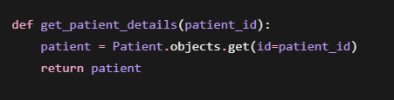

17.2 Django Model Standards
Models should represent database entities clearly. Model names use singular PascalCase, while fields use snake_case.
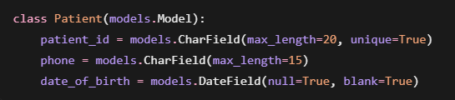

17.3 Django View Standards
Views should contain only the logic required to process the request and return a response.
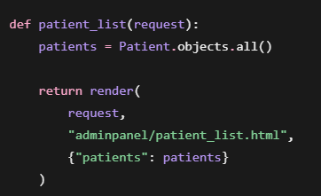
Repeated business logic should not be unnecessarily duplicated across different views.

17.4 URL Naming Standards
URLs should be simple and descriptive.
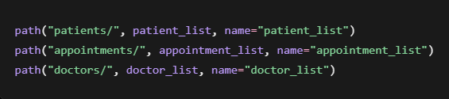
Use Django URL names in templates rather than hard-coded URLs:
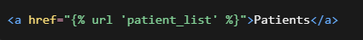

17.5 Template Standards
Django templates should mainly handle presentation. Complex database or business logic should remain in Python code.
Template files should have meaningful names:
patient_list.html
patient_profile.html
doctor_dashboard.html
appointment_list.html
generate_report.html
Template inheritance should be used where possible:
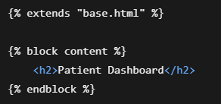

17.6 HTML Standards
Use semantic and properly structured HTML.
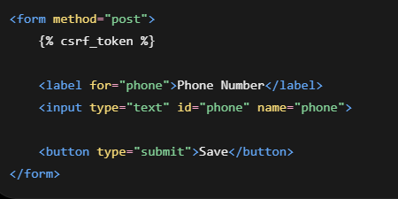
Indent nested elements consistently and use meaningful id and class names.

17.7 CSS Standards
CSS classes should describe their purpose.
Recommended:
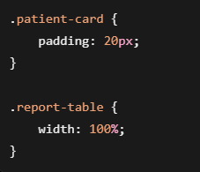
Avoid unclear names such as:
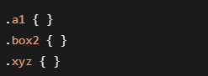
should be placed in reusable CSS files rather than repeatedly written inline.

17.8 JavaScript Standards
JavaScript variables and functions should use camelCase.
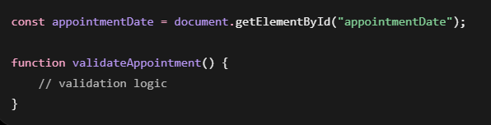
JavaScript should mainly be used for client-side interaction and validation, while important validation and security checks must also be performed by Django on the server.

17.9 Database Standards
Database tables and relationships should be controlled through Django models and migrations.
For example:
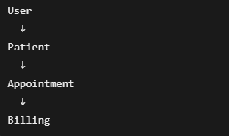
Primary keys, foreign keys, unique constraints, and appropriate field types should be used to maintain data integrity.
Changes to models should be followed by:


17.10 Security Standards
The HMS contains personal and medical information, so security-related practices are important.
Passwords should use Django's authentication system and should never be stored as plain text. Protected pages should require authentication and appropriate role checks. Forms that modify data should use CSRF protection:

Sensitive configuration such as database passwords, email credentials, secret keys, and API credentials should be stored in environment variables rather than directly inside source code.
Your HMS already uses role-based access for Super Admin, Doctor, Patient, and Receptionist, so users should only be allowed to access operations appropriate to their roles. HOSPITAL MANAGEMENT SYSTEM

17.11 Error Handling
Expected errors should be handled gracefully rather than exposing raw exceptions to users.
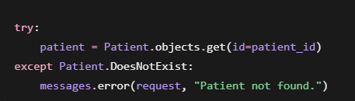
User-facing error messages should be simple and understandable.

17.12 Comments and Documentation
Comments should only be added when they explain logic that is not obvious from the code itself.

# Prevent booking appointments for past dates
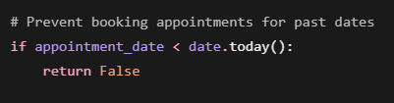
Avoid comments that simply repeat the code.

17.13 Git Standards
Changes should be tracked through Git and GitHub. Commit messages should briefly describe the change.
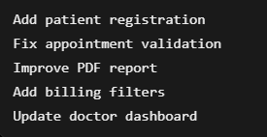
Generated files, virtual environments, .env files, cache files, and other unnecessary local files should be excluded through .gitignore.

17.14 General Coding Rules
For this HMS, the team should follow these general principles:
- Keep code simple and beginner-friendly.
- Use meaningful variable, function, class, template, and URL names.
- Maintain consistent indentation and formatting.
- Avoid duplicate code.
- Separate backend logic from frontend presentation.
- Validate important data on the server.
- Do not hard-code passwords or secret information.
- Use Django ORM rather than manually constructing SQL where possible.
- Test important functionality after making changes.
- Prefer clear code over unnecessarily complicated implementations.

18.USER INTERFACE DESIGN
The User Interface (UI) of the Hospital Management System is designed to provide a simple, clear, and role-based experience for all users. The system provides separate interfaces for the Super Admin, Doctor, Patient, and Receptionist according to their responsibilities.
The interface is developed using HTML, CSS, JavaScript, and Bootstrap, while Django is used to process user requests and communicate with the database. The UI provides navigation, forms, tables, dashboards, and other components required to perform hospital management operations.
The following screens represent the major user interfaces of the Hospital Management System.
18.1 Login Page
The Login Page provides secure access to the Hospital Management System. Registered users can enter their login credentials to access the system. After successful authentication, the system identifies the user's role and redirects the user to the appropriate dashboard.
The system supports Super Admin, Doctor, Patient, and Receptionist accounts.
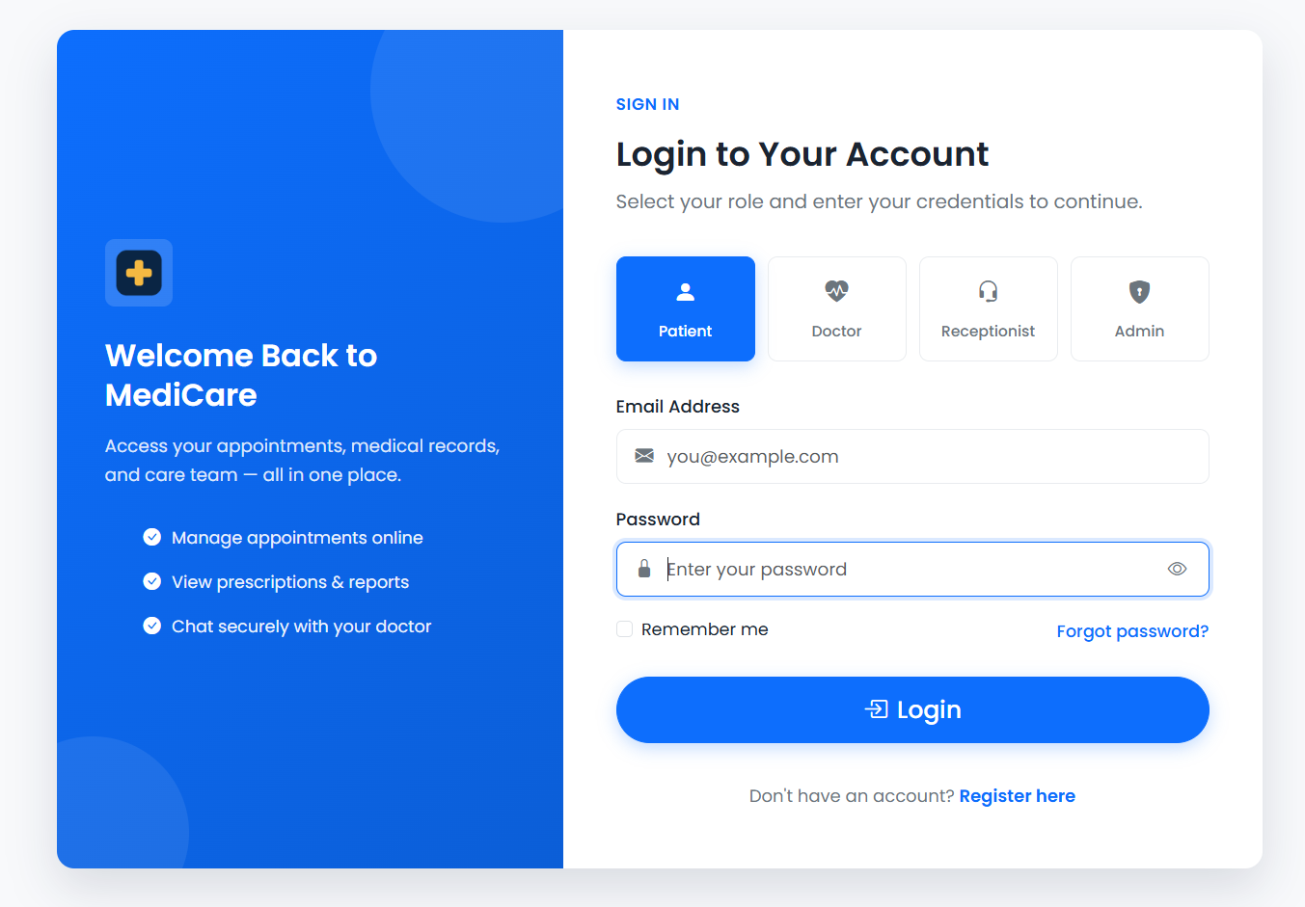
Figure 18.1: Hospital Management System Login Page

18.2 OTP Verification Page
The OTP Verification Page provides an additional level of authentication. When two-step OTP verification is enabled, an OTP is sent to the user's registered email address after successful credential verification.
The user must enter the valid OTP before accessing the system. The Super Admin can enable or disable this OTP requirement for the entire system from the security settings. This behavior is part of the authentication requirements documented in the project. HOSPITAL MANAGEMENT SYSTEM
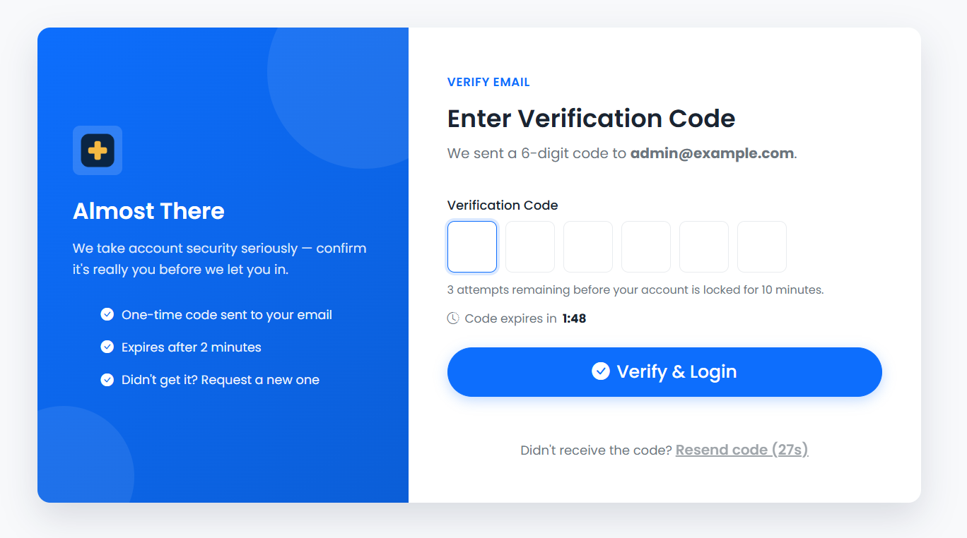Figure 18.2: OTP Verification Page

18.3 SUPER ADMIN INTERFACE
The Super Admin interface provides overall administrative control of the Hospital Management System. The administrator can manage doctors, receptionists, patients, user accounts, billing information, reports, and system settings. HOSPITAL MANAGEMENT SYSTEM
18.3.1 Super Admin Dashboard
The Super Admin Dashboard provides an overview of important hospital information. It acts as the main navigation point for administrative activities and provides quick access to different management modules.
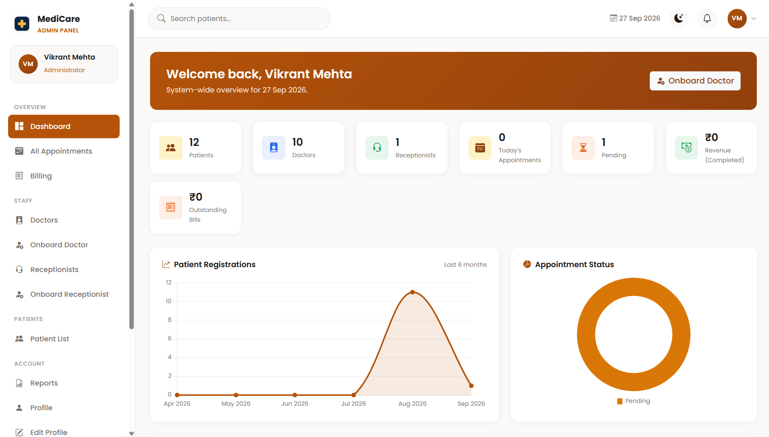Figure 18.3: Super Admin Dashboard
18.3.2 Doctor Management
The Doctor Management interface allows the Super Admin to view and manage doctor information. Doctor details such as department, specialization, qualification, experience, consultation fee, and availability can be maintained through the system.
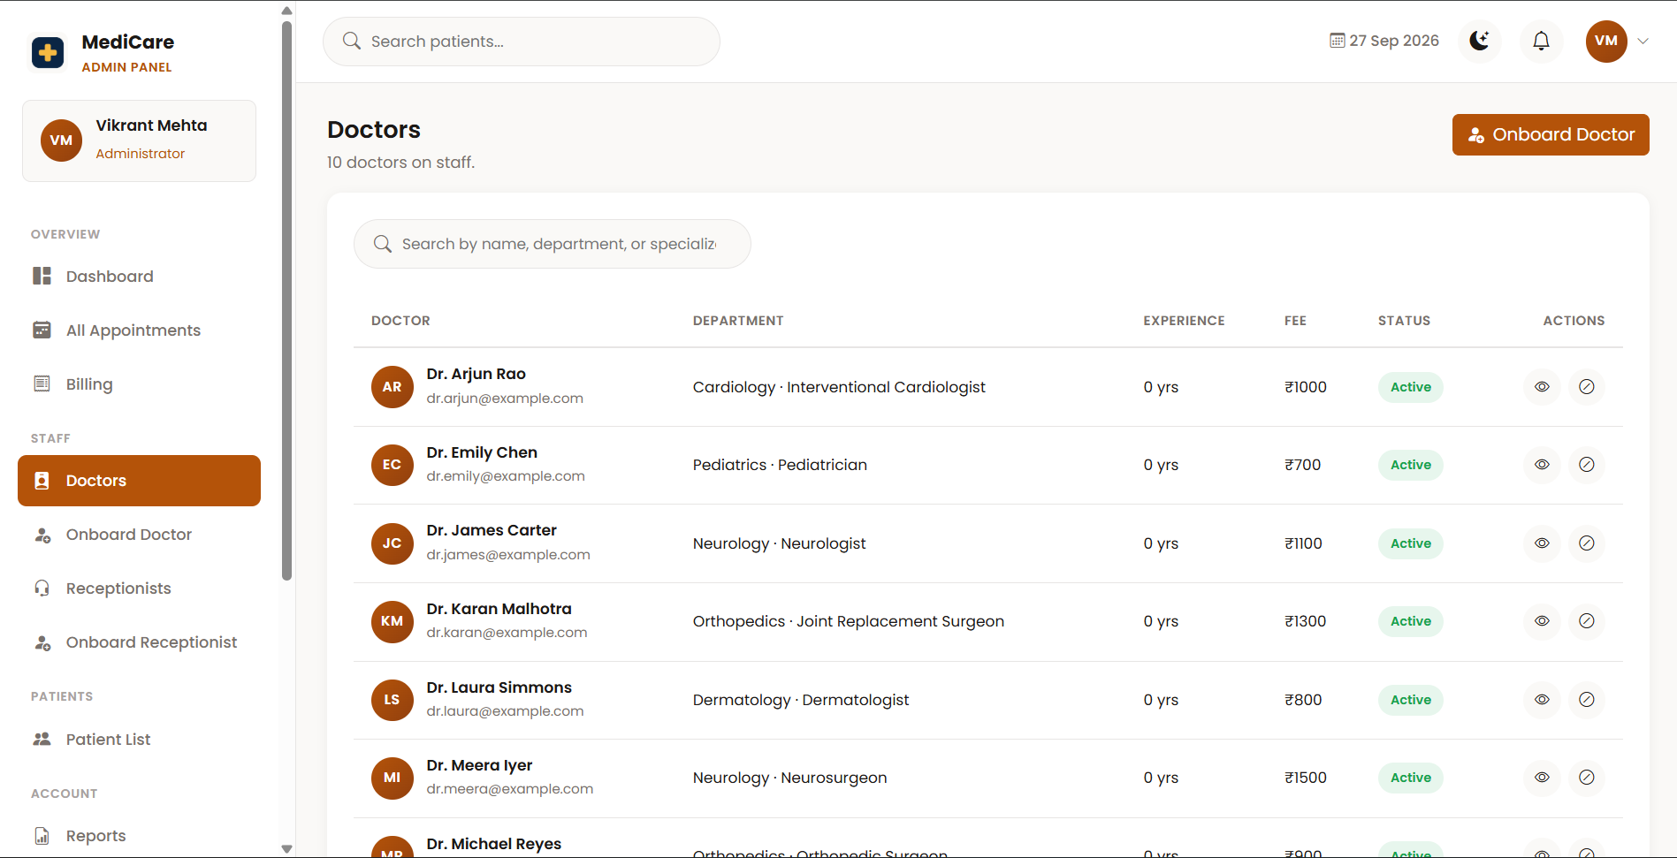Figure 18.4: Doctor Management Page
18.3.3 Add Doctor
The Add Doctor interface is used to register a new doctor in the Hospital Management System. The administrator enters the required personal and professional information to create the doctor account and profile.
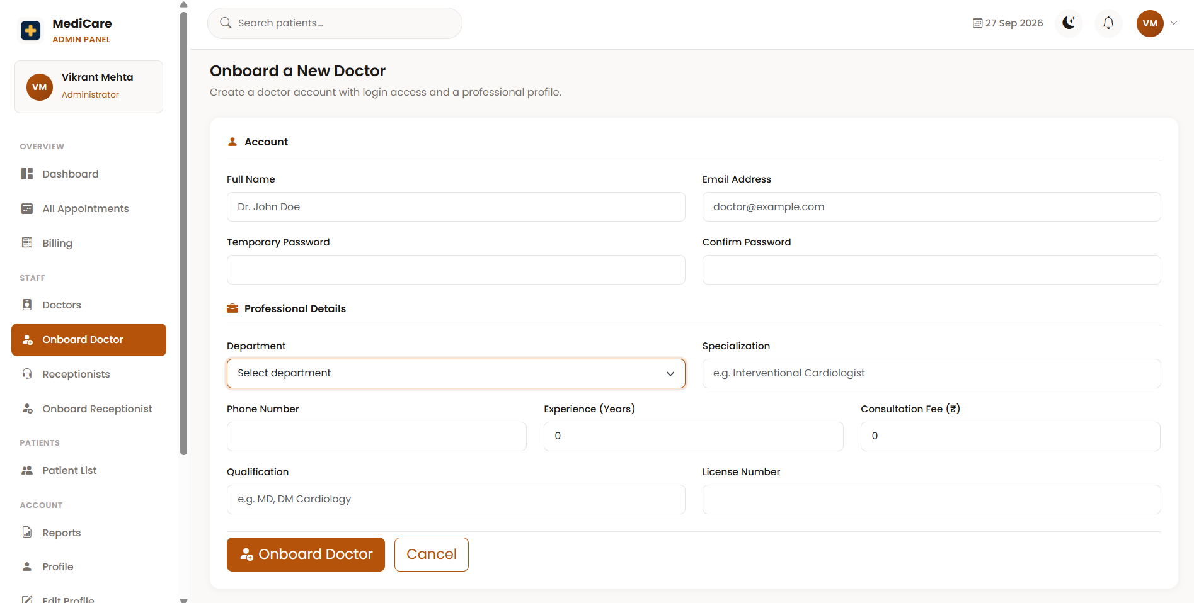Figure 18.5: Add Doctor Page
18.3.4 Receptionist Management
The Receptionist Management interface allows the Super Admin to manage receptionist accounts and related information. It helps maintain the front-desk staff records required by the hospital.
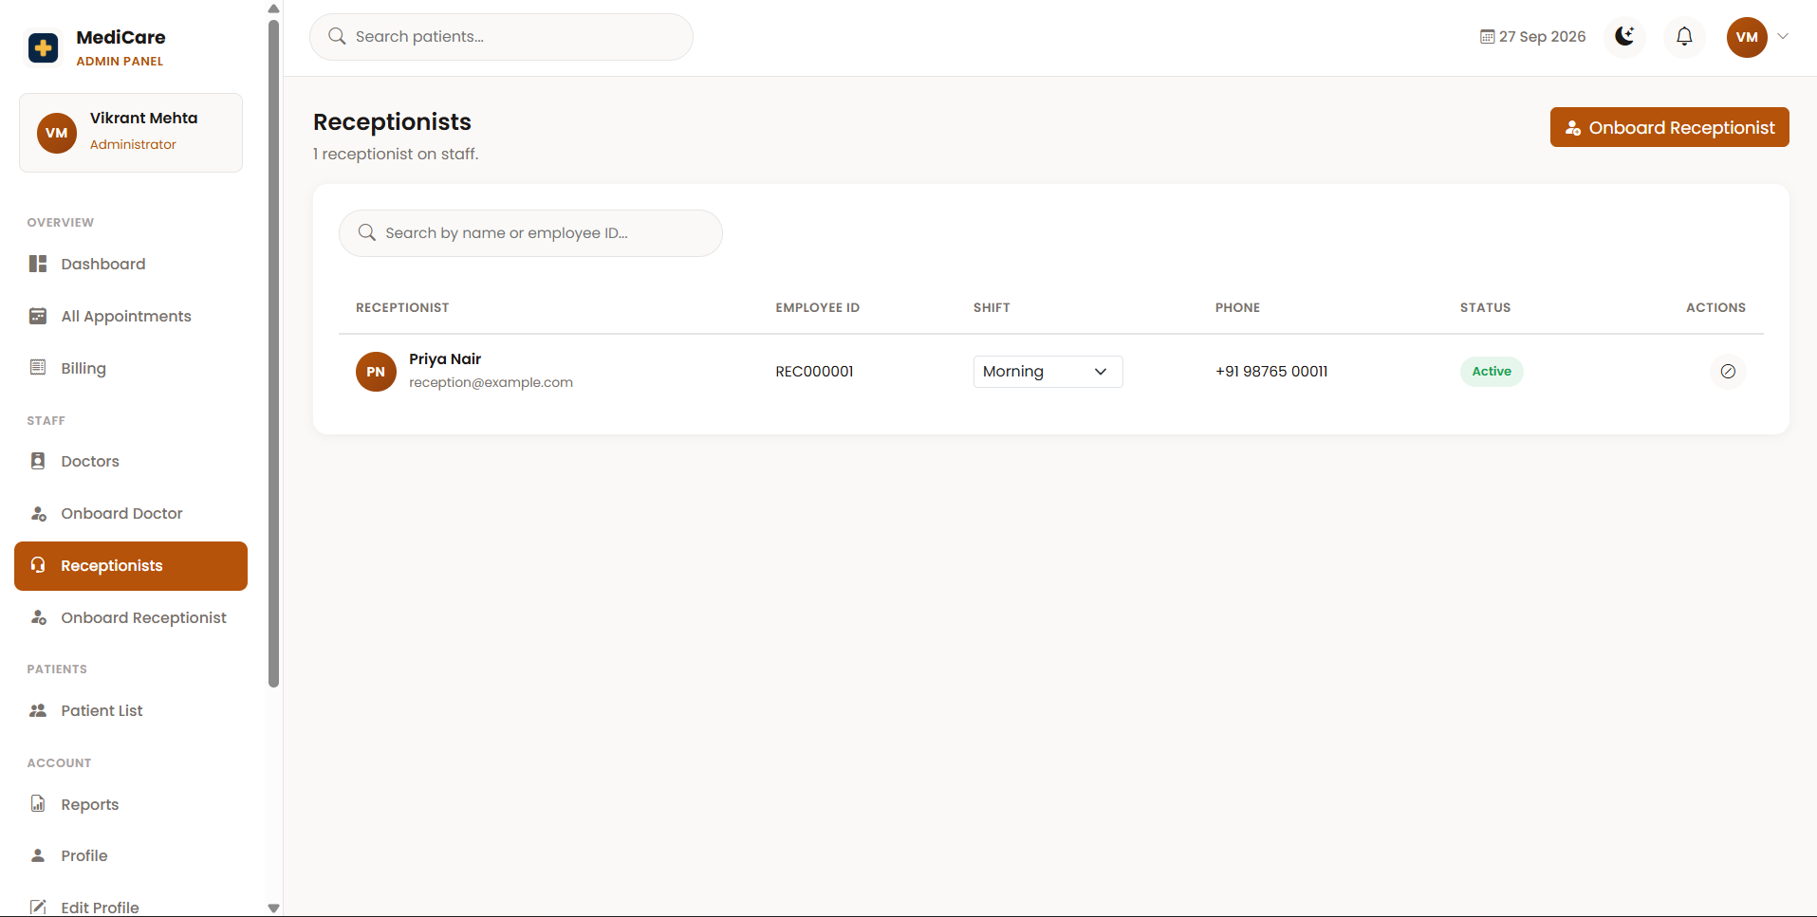Figure 18.6: Receptionist Management Page
18.3.5 Patient Management
The Patient Management interface allows the administrator to view and manage patient records stored in the system. It provides centralized access to patient information for authorized administrative operations.
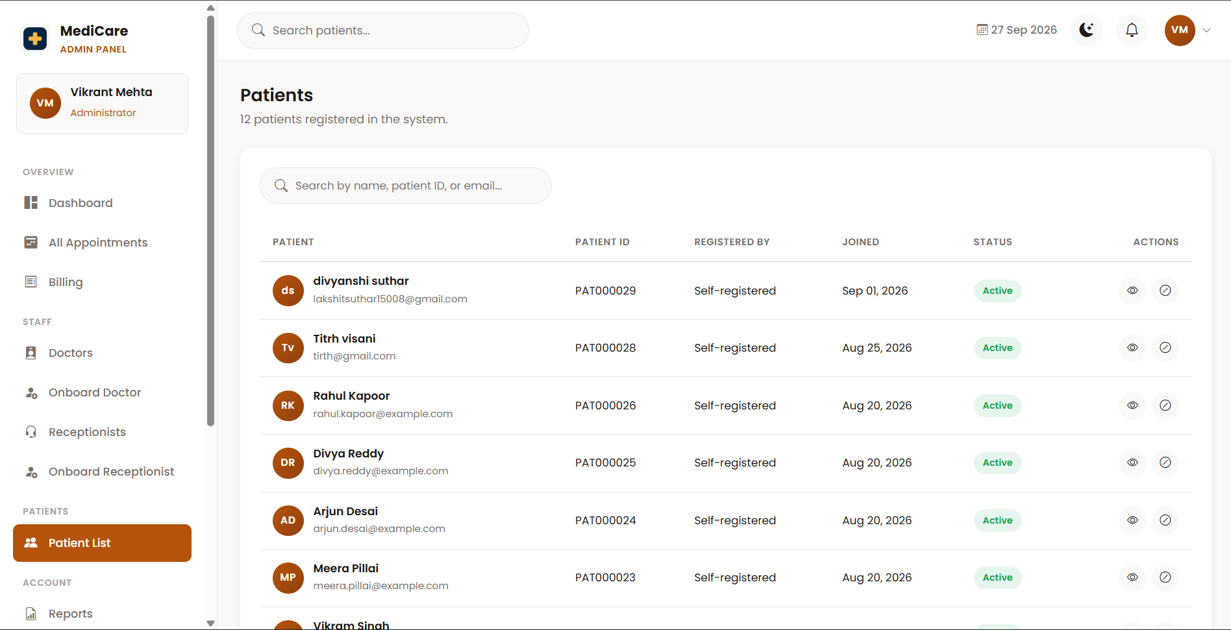
Figure 18.7: Patient Management Page

18.3.6 Appointment Management
The Appointment Management interface provides information about appointments booked in the system. The administrator can review appointment information such as patient, doctor, department, appointment date, time, and current status.
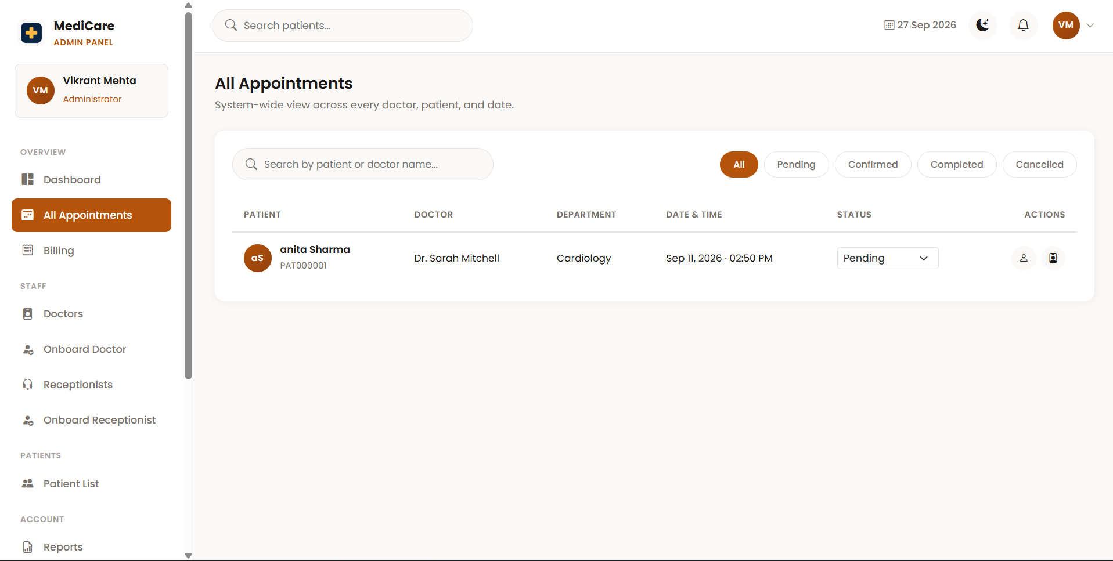
Figure 18.8: Appointment Management Page
18.3.7 Billing Management
The Billing Management interface provides access to patient billing records. Bills are associated with appointments, and authorized users can review payment information and update permitted billing statuses.
The project currently handles appointment billing and no-show fees, while online payment processing is outside the current scope. HOSPITAL MANAGEMENT SYSTEM

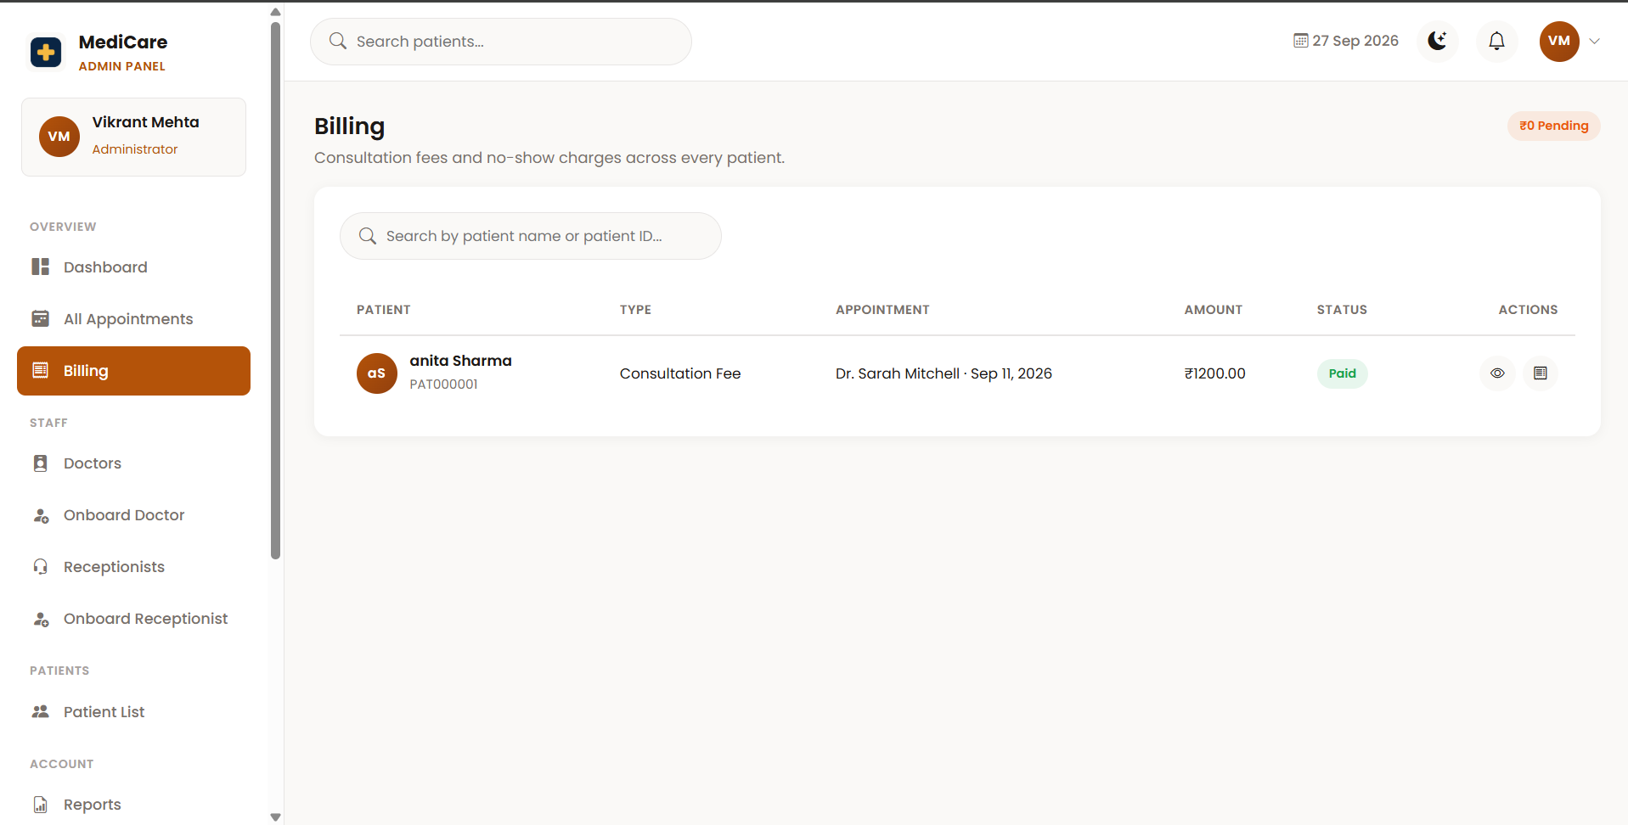
Figure 18.9: Billing Management Page
18.3.8 Report Generation
The Report Generation interface allows the Super Admin to generate reports related to hospital operations. Reports can be created for important information such as patients, doctors, appointments, and billing.
Filters help the administrator retrieve relevant information according to the selected report requirements.
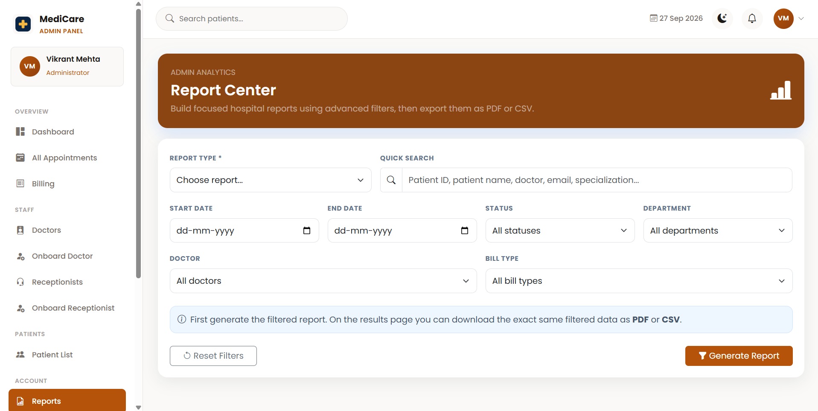Figure 18.10: Report Generation and Filter Page
18.3.9 Report Result
The Report Result interface displays the records produced using the selected report type and filters. The report information is presented in a structured tabular format for easier review.
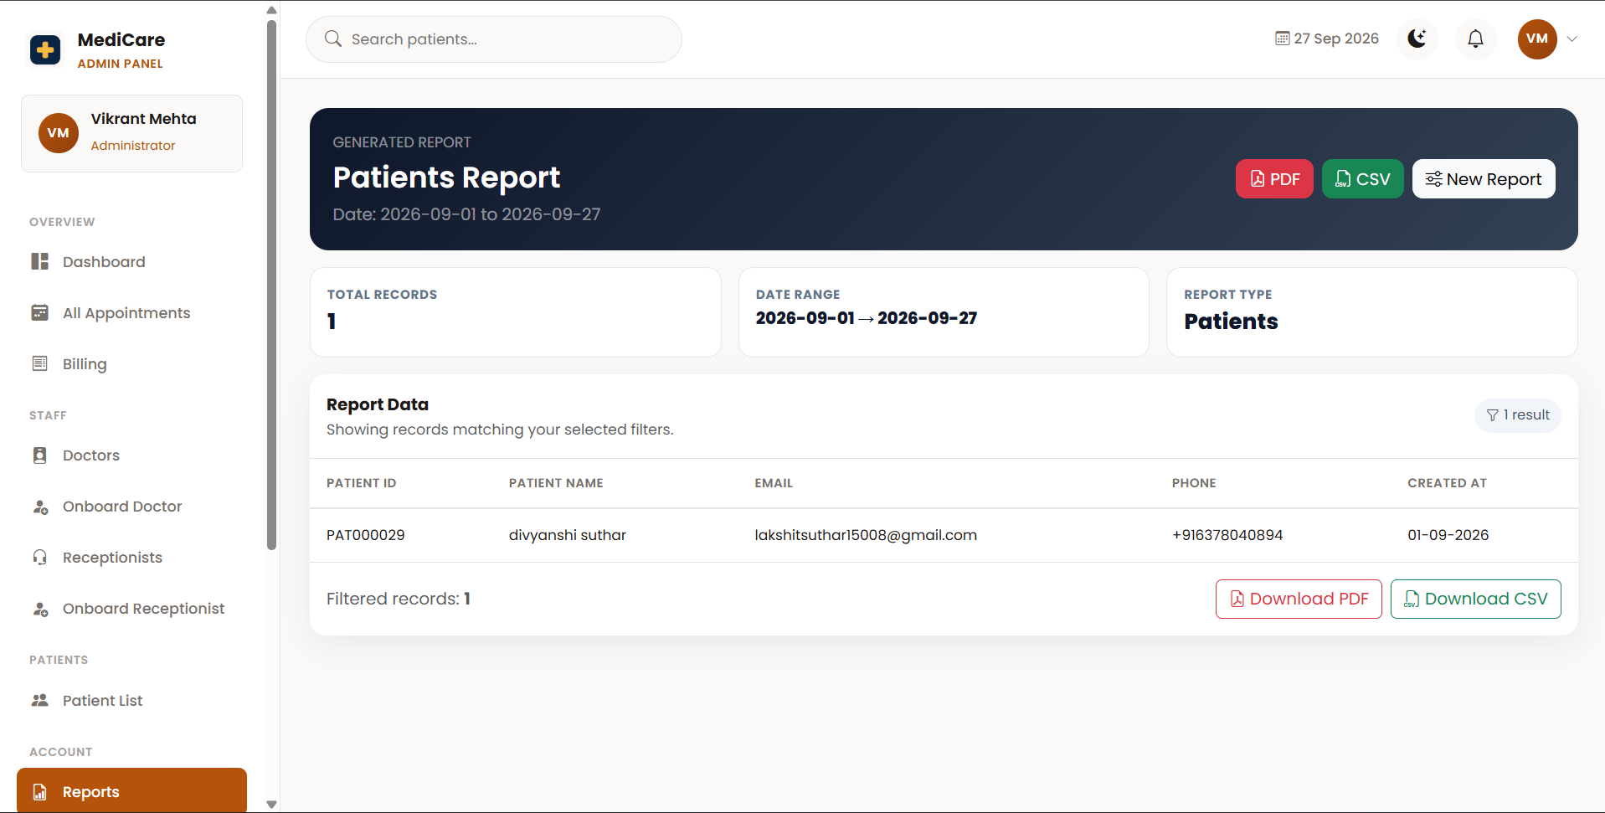Figure 18.11: Generated Report Result
18.3.10 PDF Report
The Hospital Management System provides a downloadable PDF representation of report information. The PDF presents report details in a structured format that can be stored or printed for administrative use.
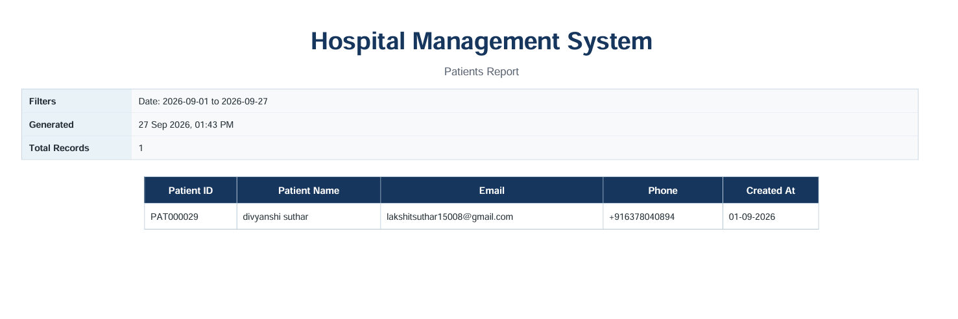Figure 18.12: Generated PDF Report
18.3.11 Security Settings
The Security Settings interface allows the Super Admin to control the system-wide two-step OTP login requirement.
The administrator can enable OTP verification when additional login verification is required or disable it according to system requirements without changing the source code. HOSPITAL MANAGEMENT SYSTEM
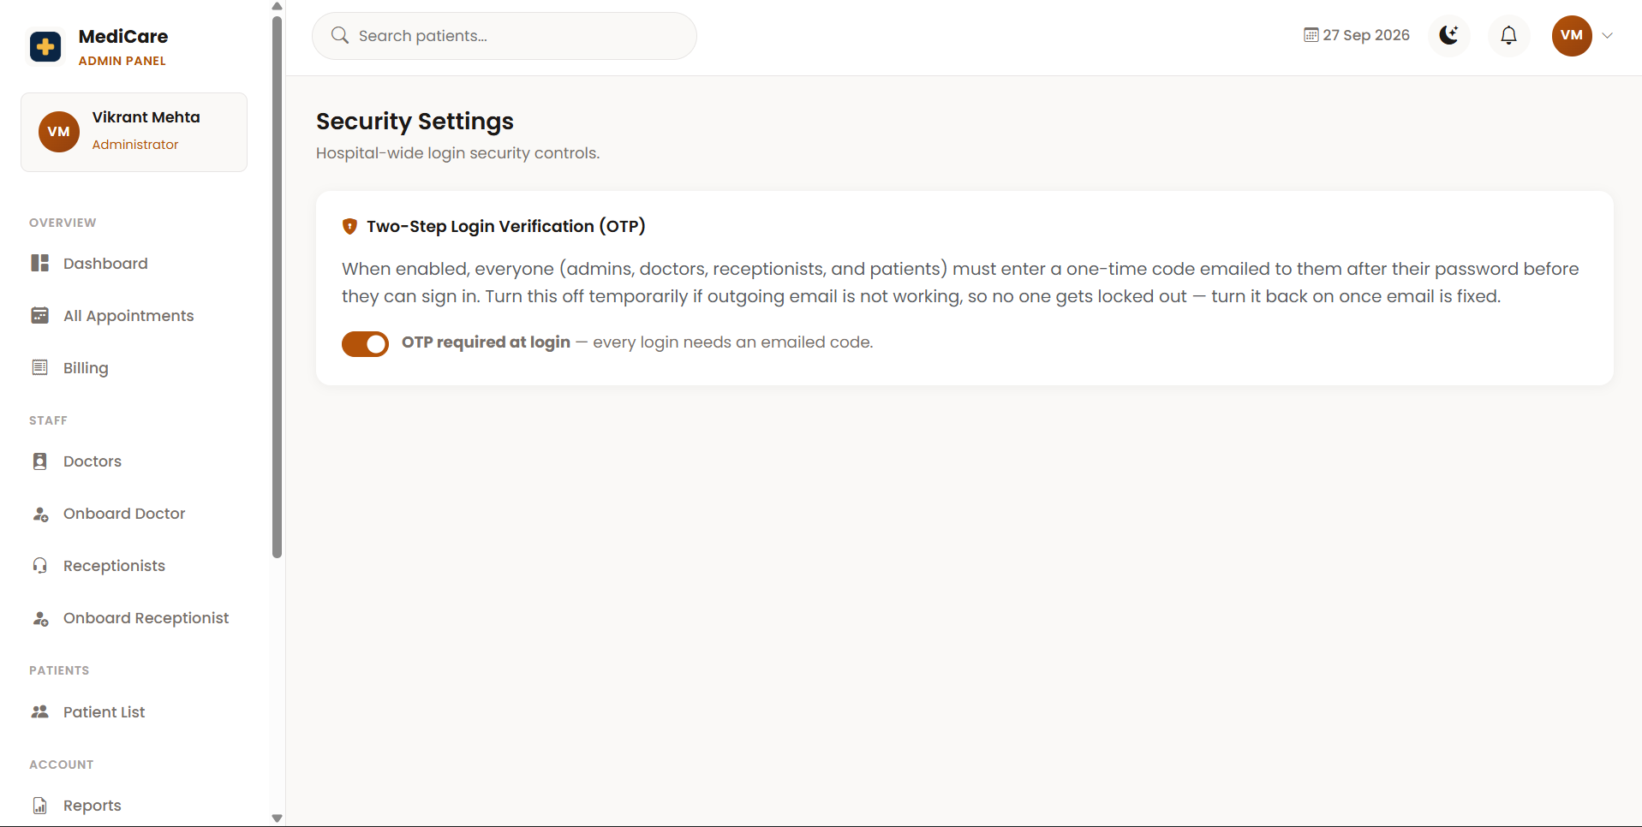Figure 18.13: OTP Security Settings
18.4 DOCTOR INTERFACE
The Doctor interface is designed to help doctors manage their hospital activities. Doctors can view assigned appointments, access authorized patient information, enter diagnosis information, and manage prescriptions. HOSPITAL MANAGEMENT SYSTEM
18.4.1 Doctor Dashboard
The Doctor Dashboard provides an overview of information relevant to the logged-in doctor. It provides quick access to appointments, patient information, prescriptions, and other available doctor functions.
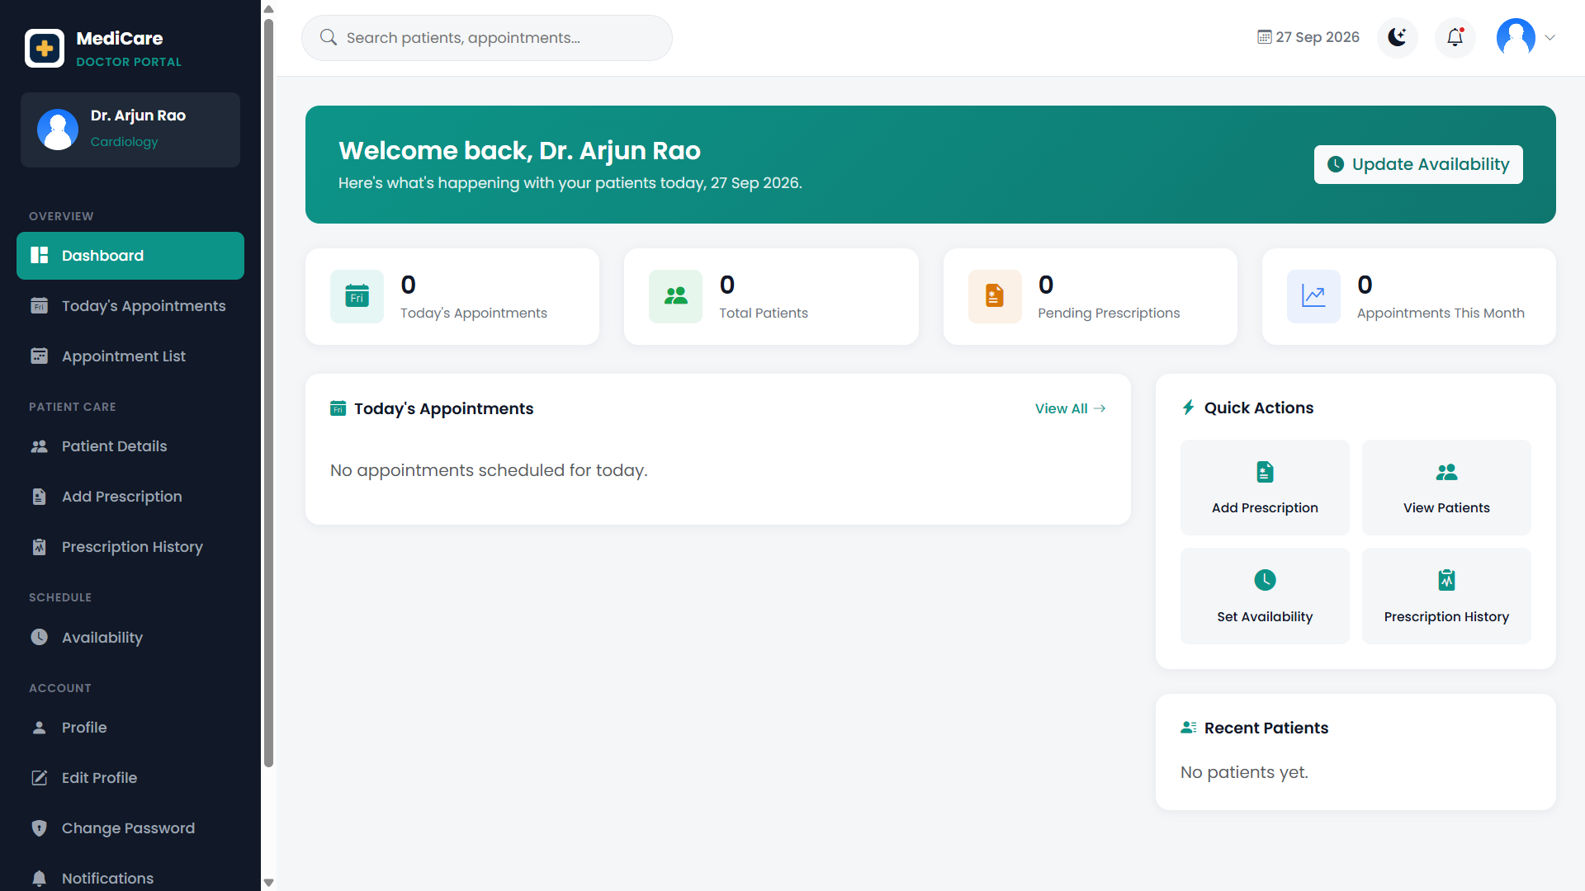
SSFigure 18.14: Doctor Dashboard
18.4.2 Doctor Appointment List
The Appointment interface allows doctors to view appointments assigned to them. Appointment information helps the doctor identify the patient, appointment schedule, and current appointment status.
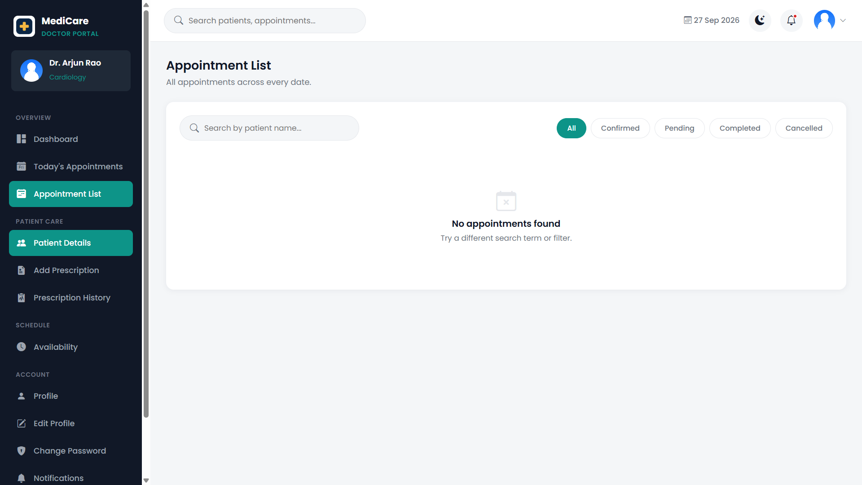
Figure 18.15: Doctor Appointment List
18.4.3 Patient Details
The Patient Details interface allows the doctor to view authorized patient information required during treatment. This can include profile information and available medical information according to the doctor's access permissions.
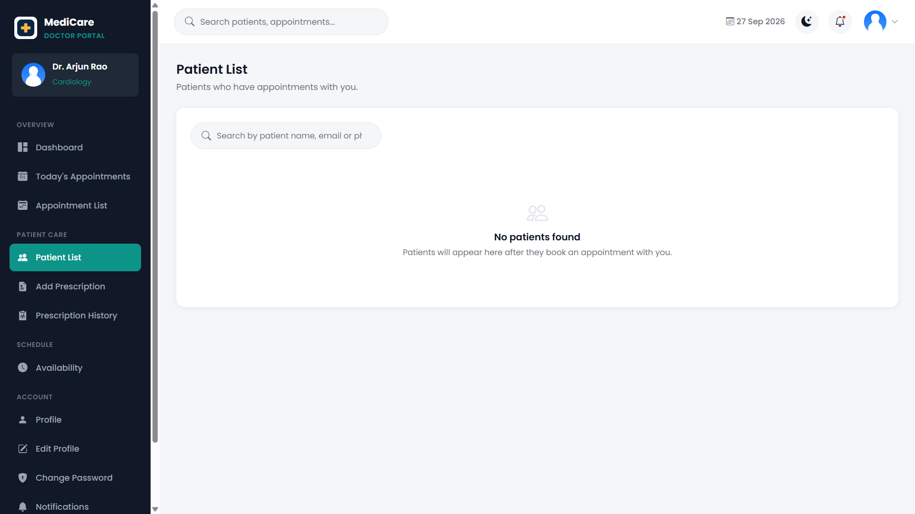
Figure 18.16: Patient Details for Doctor
18.4.4 Prescription Management
The Prescription interface allows doctors to create and manage prescriptions for patients. The doctor can record diagnosis information, medicines, dosage information, instructions, and other relevant treatment details available in the system.
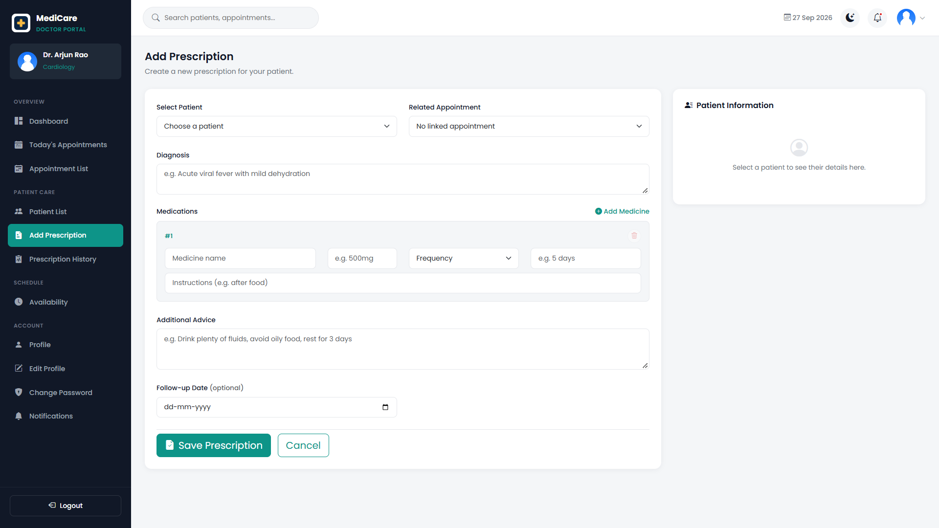
Figure 18.17: Prescription Management Page
18.4.5 Doctor Availability
The Doctor Availability interface is used to maintain the doctor's available working schedule. Availability information helps the appointment system determine when appointments can be scheduled.
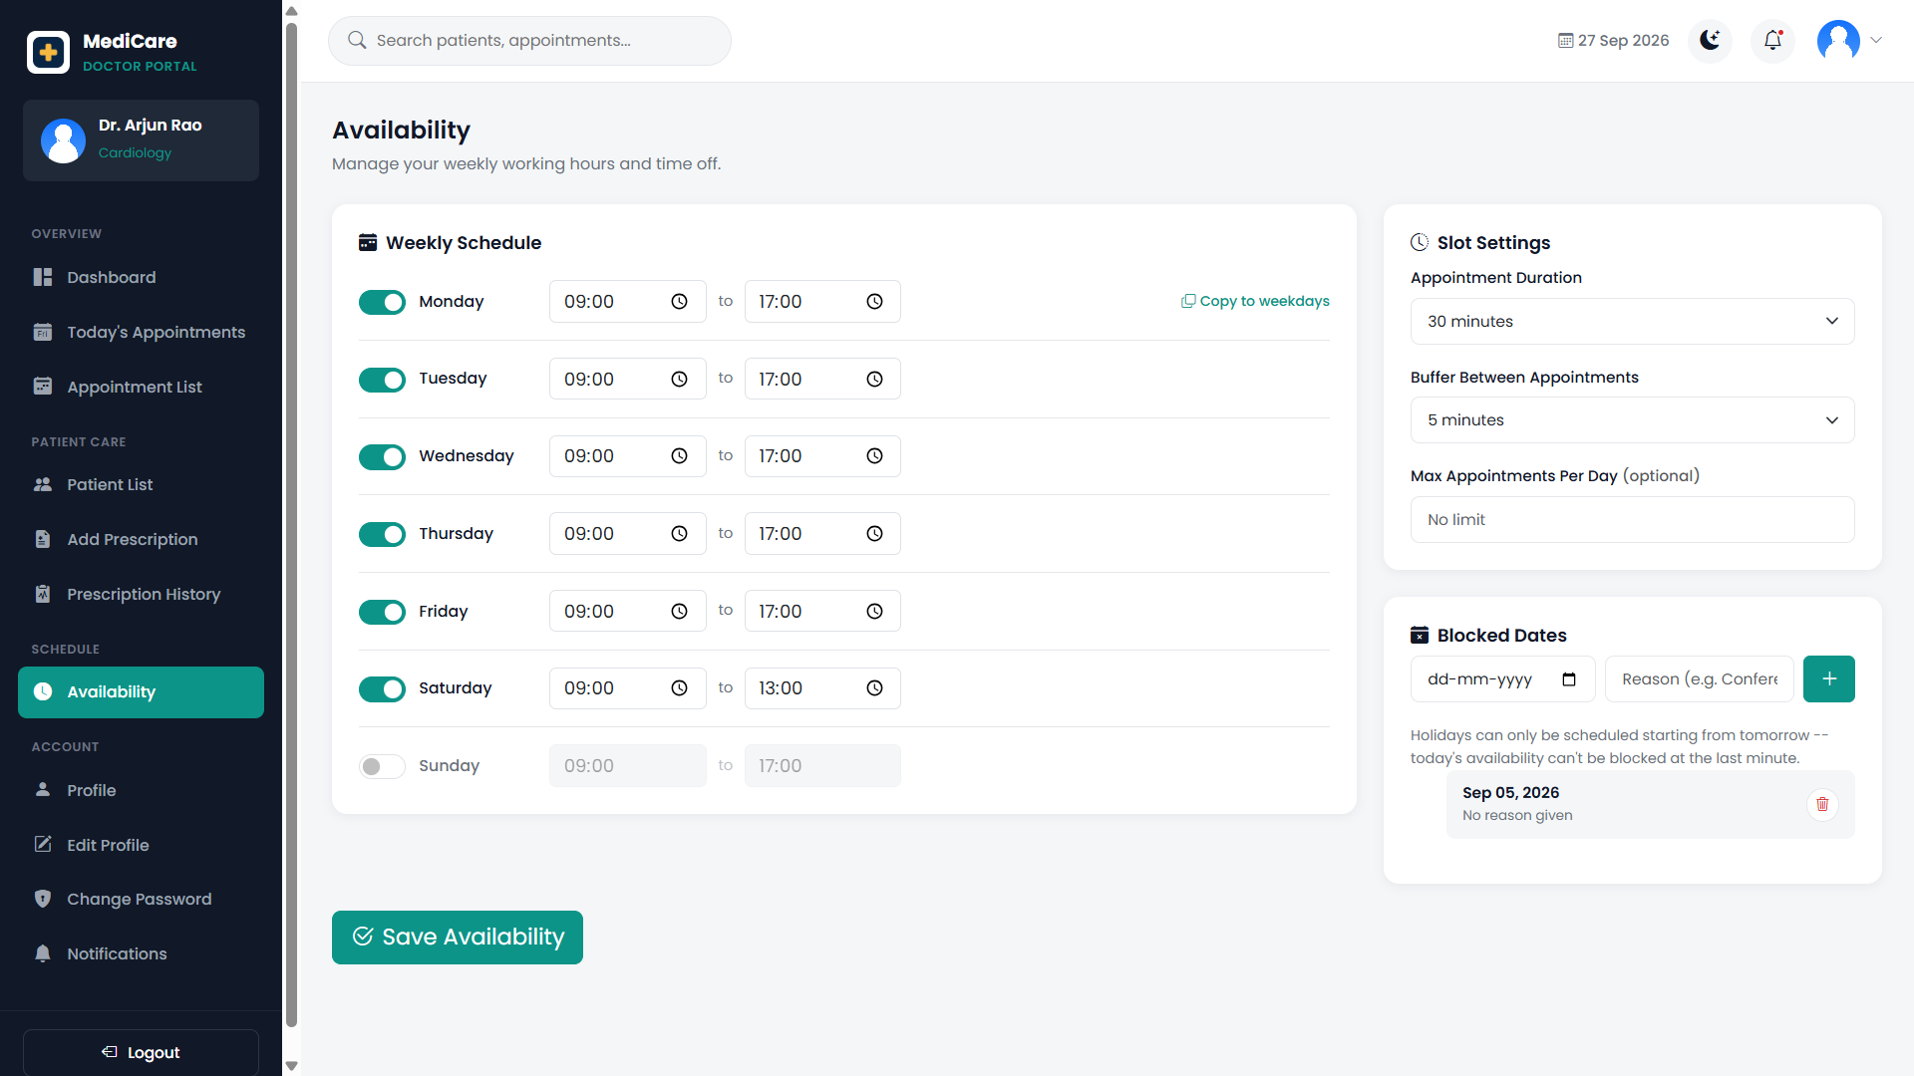Figure 18.18: Doctor Availability Management
18.4.6 Doctor Profile
The Doctor Profile interface displays the professional and personal information associated with the logged-in doctor.
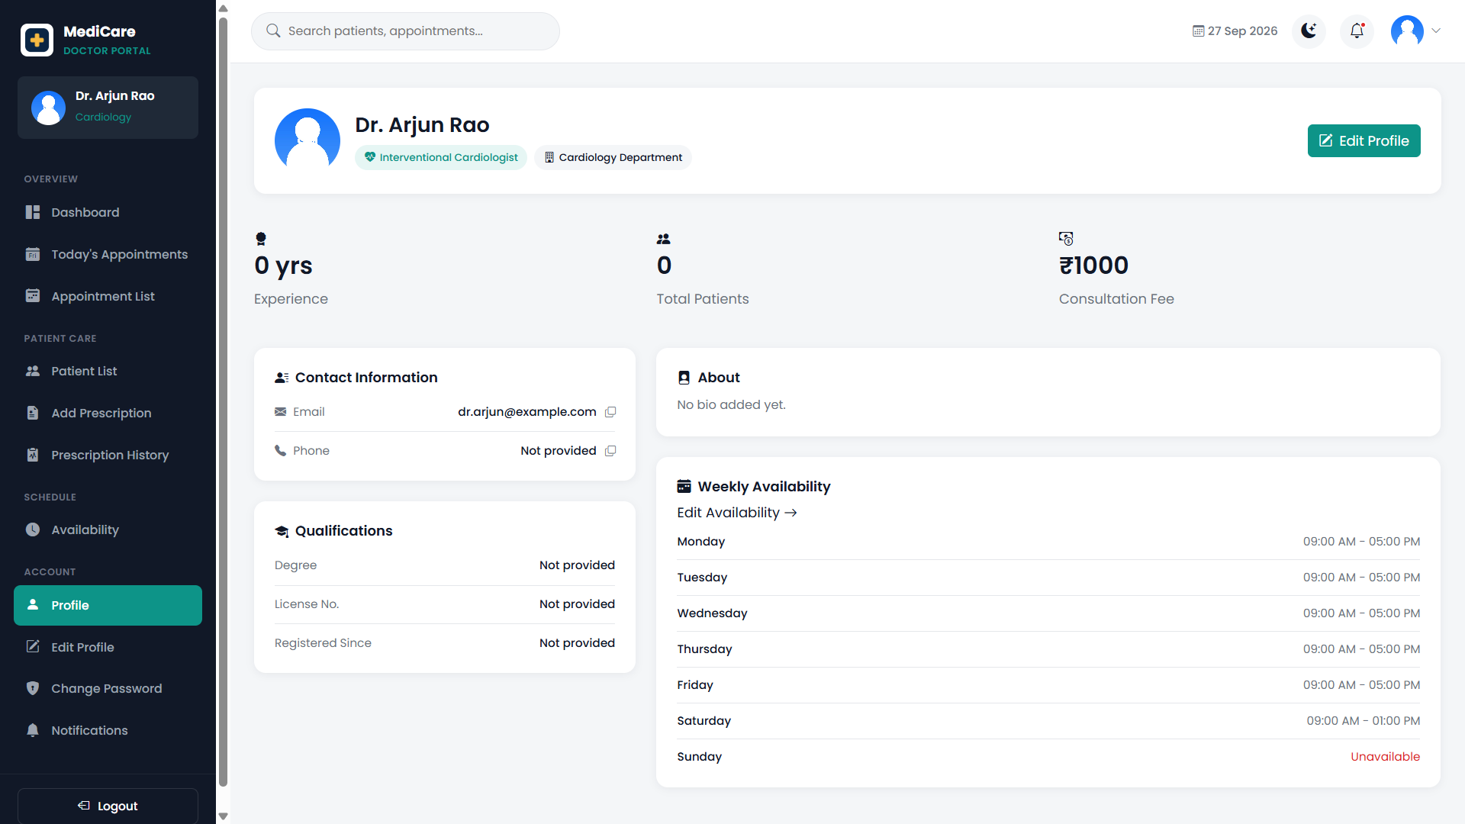
Figure 18.19: Doctor Profile Page

18.5 PATIENT INTERFACE
The Patient Interface provides registered patients with access to the patient-related services of the Hospital Management System. After authentication, patients can access their dashboard, manage their profile information, view available doctors, book appointments, review their appointments, access billing information, and view system notifications.
The patient interface is designed to provide simple navigation and convenient access to commonly used hospital services.
18.5.1 Patient Dashboard
The Patient Dashboard provides an overview of the patient's activities and acts as a central access point for important patient functions.
The dashboard displays appointment-related information such as the number of upcoming, total, and completed appointments. It also displays upcoming appointment information and provides quick access to important functions such as Book Appointment, My Appointments, My Billing, and My Profile.

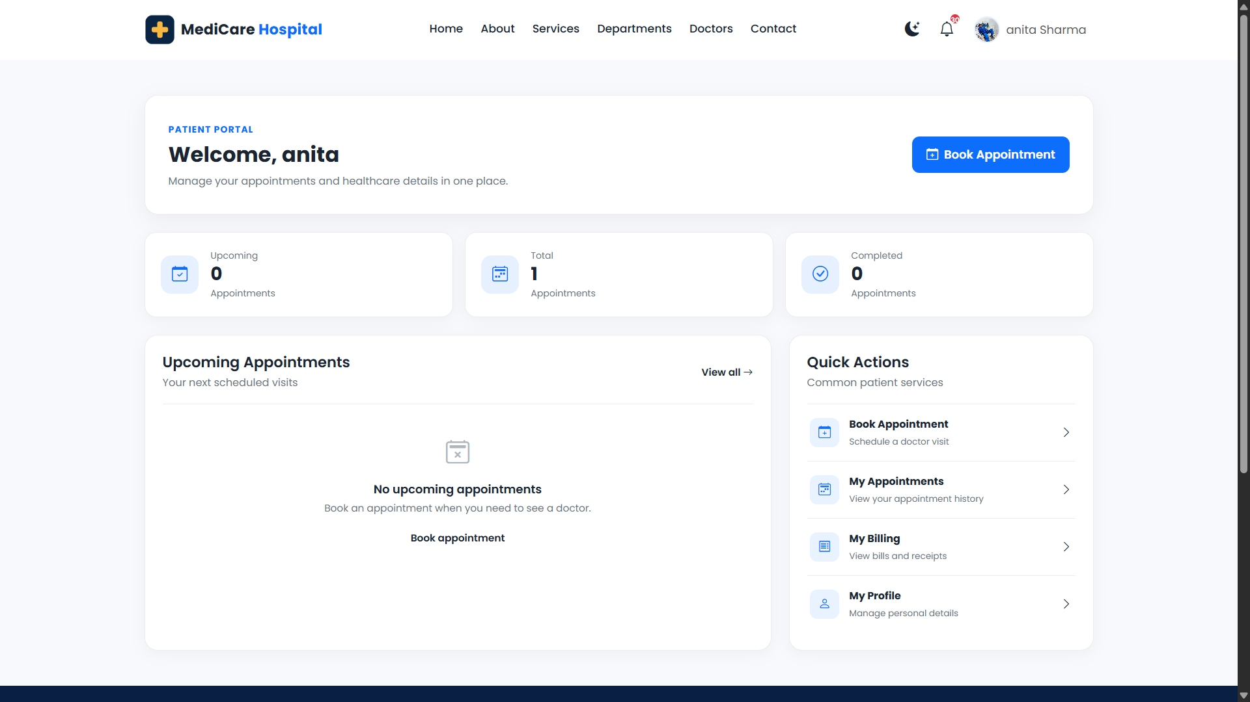Figure 18.20: Patient Dashboard

18.5.2 Patient Profile
The Patient Profile interface allows the patient to view and manage personal information stored in the Hospital Management System.
The profile page contains editable fields for information such as name, email address, phone number, date of birth, gender, blood group, address information, emergency contact details, allergies, medical history, and profile picture.
The patient can modify the permitted information directly on the Profile page and save the updated information using the Save Changes button. Therefore, a separate Edit Profile page is not required in the current system. The profile interface also provides access to password management, notifications, and appointment information.

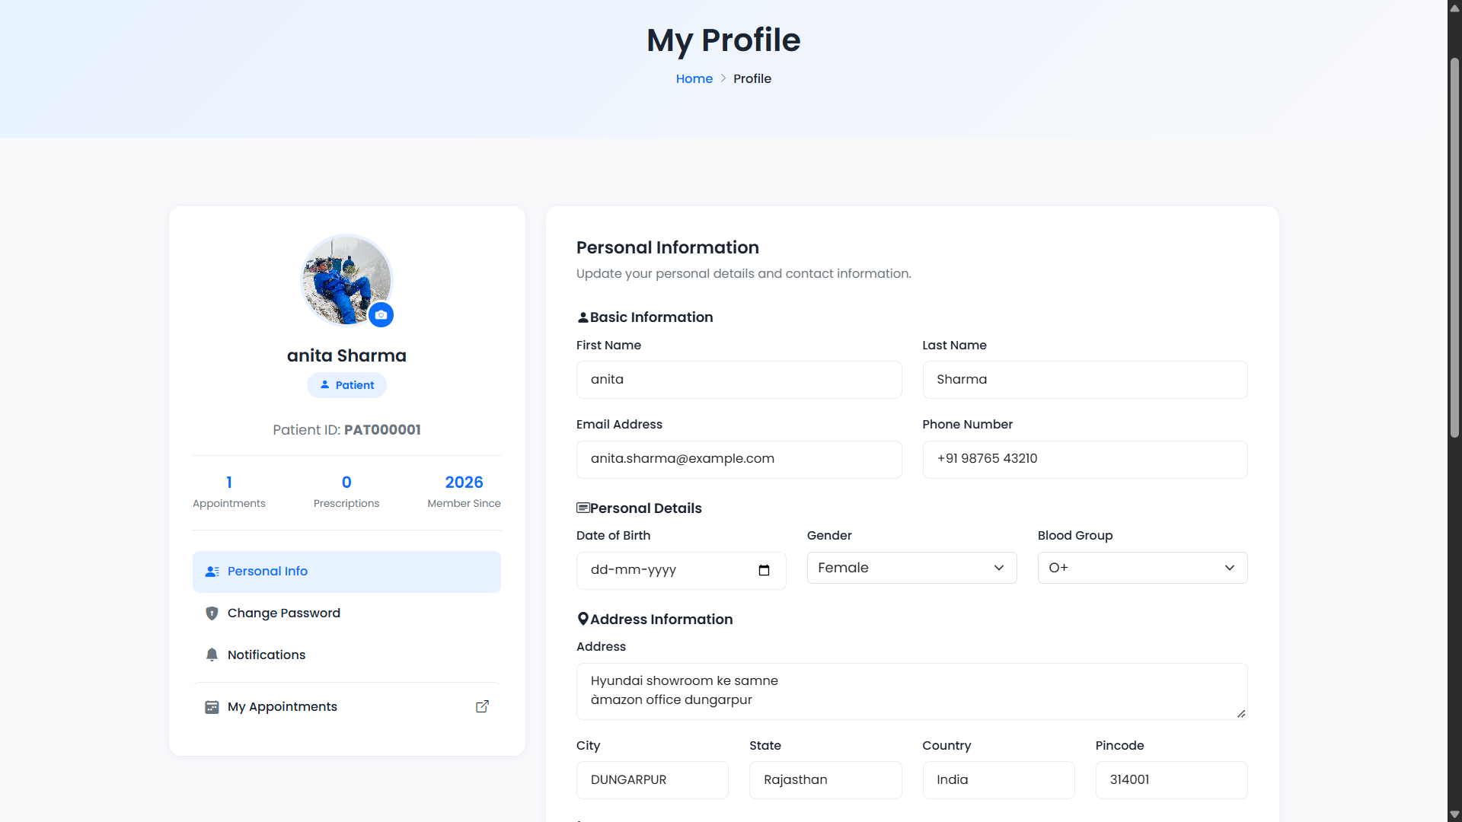Figure 18.21: Patient Profile Page

18.5.3 Our Doctors
The Our Doctors interface displays all doctors available in the Hospital Management System. It provides patients with information about the doctors registered in the system, including their names, specializations, departments, and other available professional details.
This page helps patients view and explore the hospital's doctors before selecting a suitable doctor for an appointment.
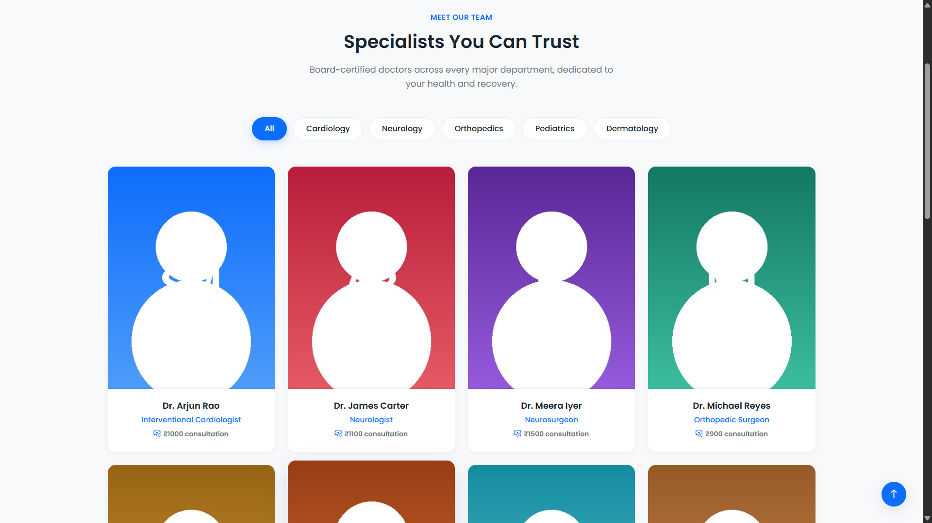 Figure 18.22: Our Doctors Page

18.5.4 Appointment Booking
The Appointment Booking interface allows an authenticated patient to schedule an appointment with a doctor.
The patient selects the required appointment information, including the doctor and available appointment details, and provides the necessary information for the hospital visit.
The system processes the appointment request and stores the appointment information in the hospital database.

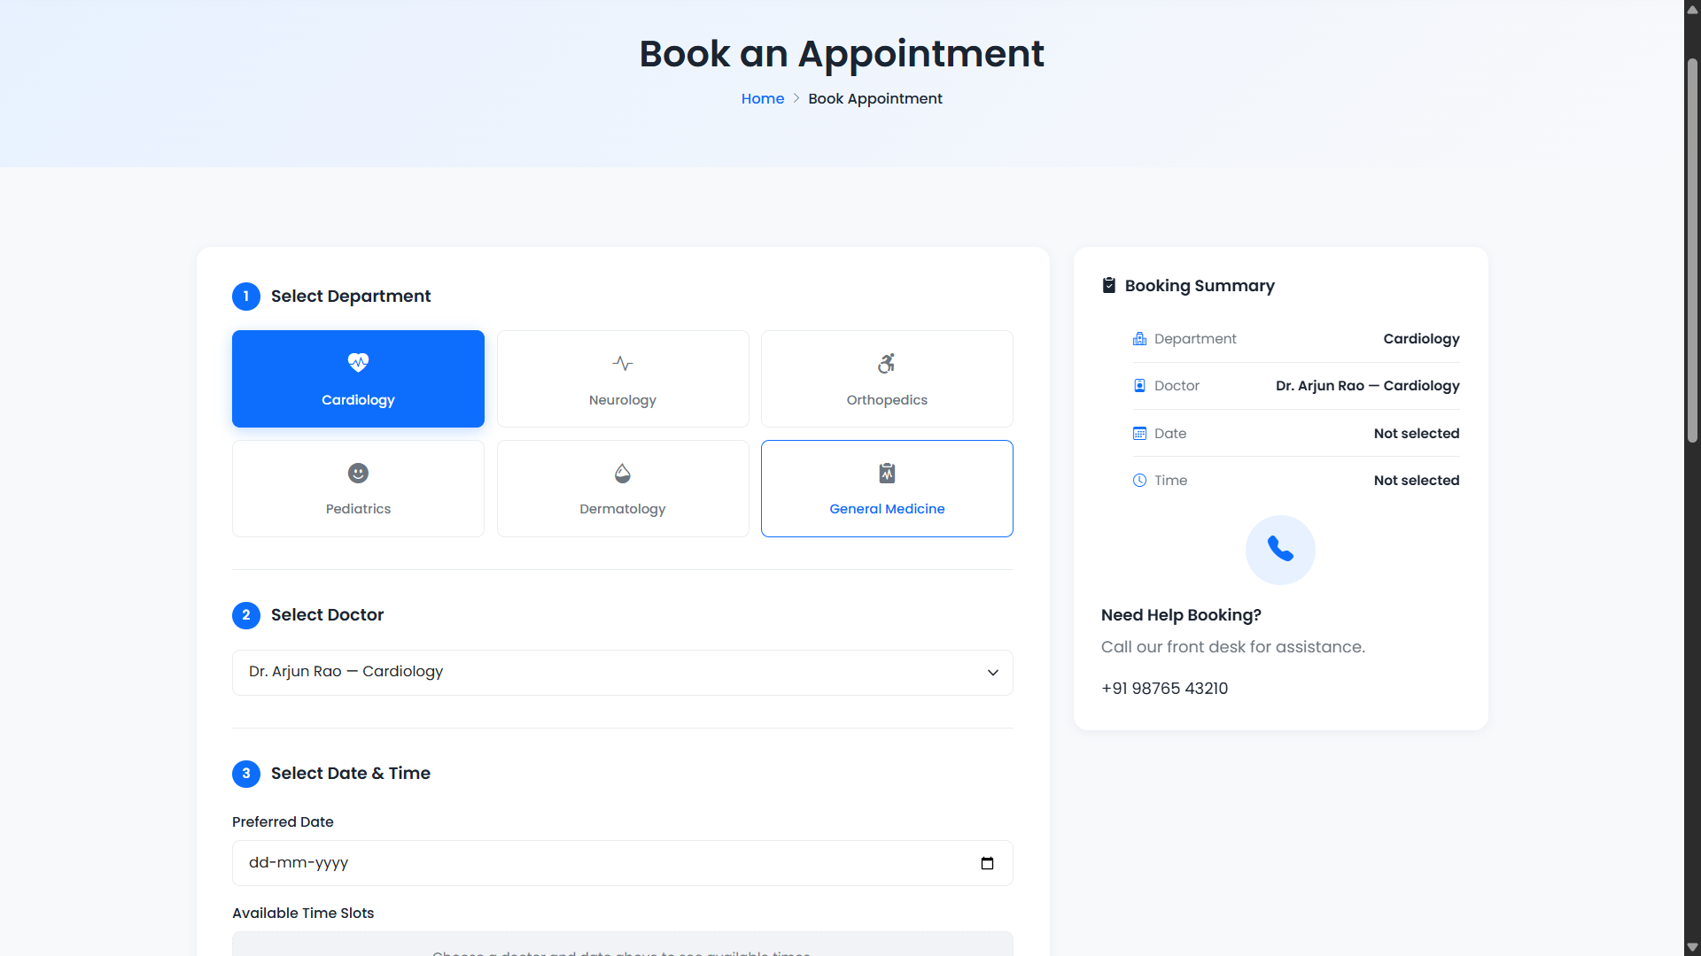Figure 18.23: Appointment Booking Page

18.5.5 My Appointments
The My Appointments interface allows patients to review appointments associated with their account.
The page provides important appointment information such as the selected doctor, appointment date, appointment time, and current appointment status.
This interface allows patients to keep track of upcoming and previous appointments from a single location.

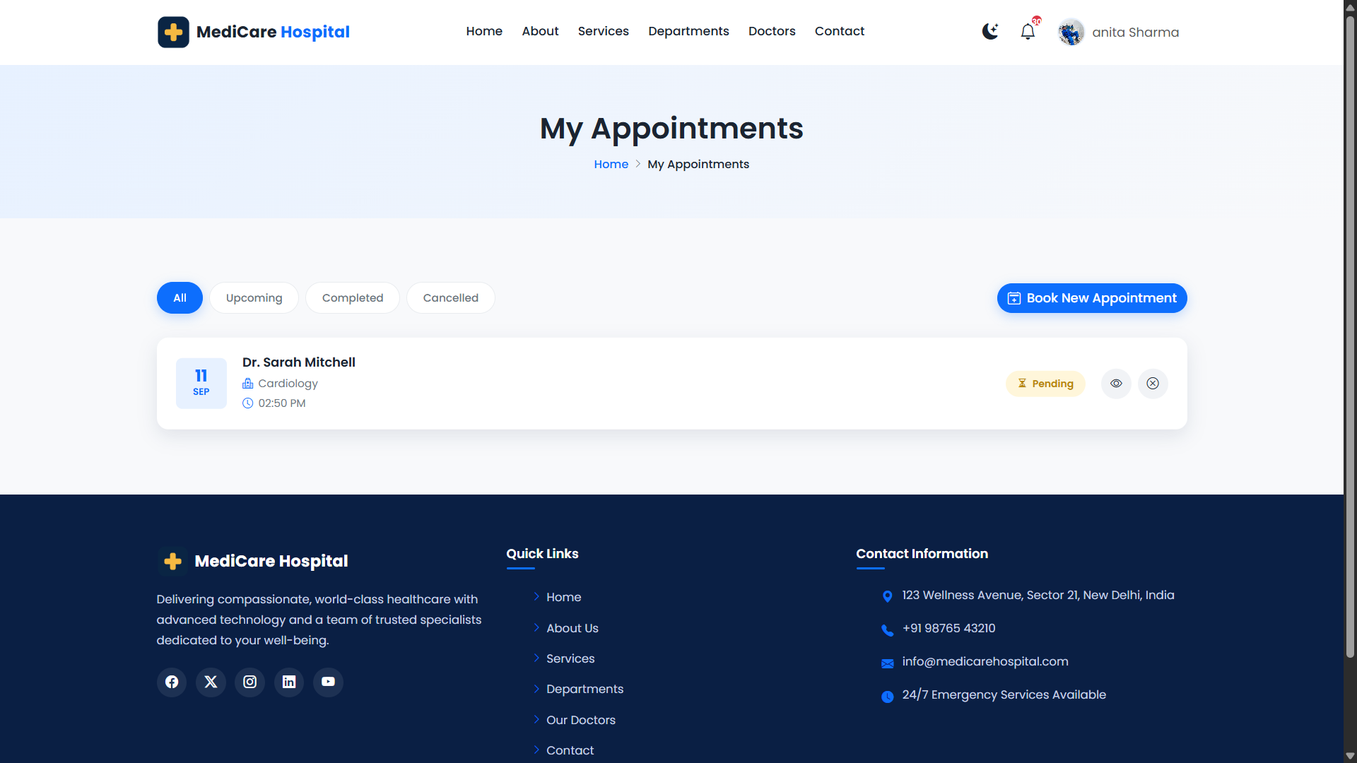Figure 18.24: Patient Appointment History

18.5.6 Billing Information
The Patient Billing interface provides access to billing information associated with patient appointments.
Patients can review available billing records and appointment-related payment information. The system also contains billing confirmation, payment-related, and billing receipt interfaces as part of the patient appointment workflow.

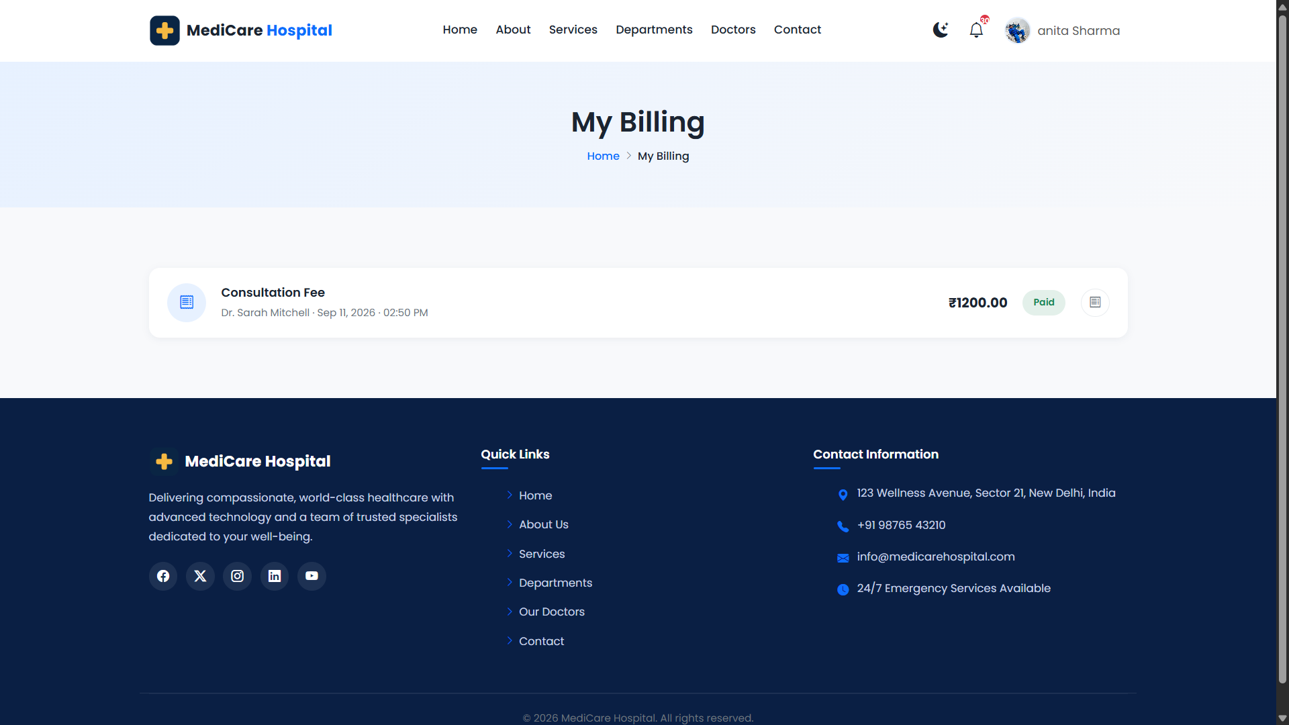Figure 18.25: Patient Billing Information

18.5.7 Notifications
The Patient Notifications interface provides information about relevant activities in the Hospital Management System.
Notifications help patients remain informed about appointment-related and account-related activities. The notification interface allows the patient to review available notifications from the system.

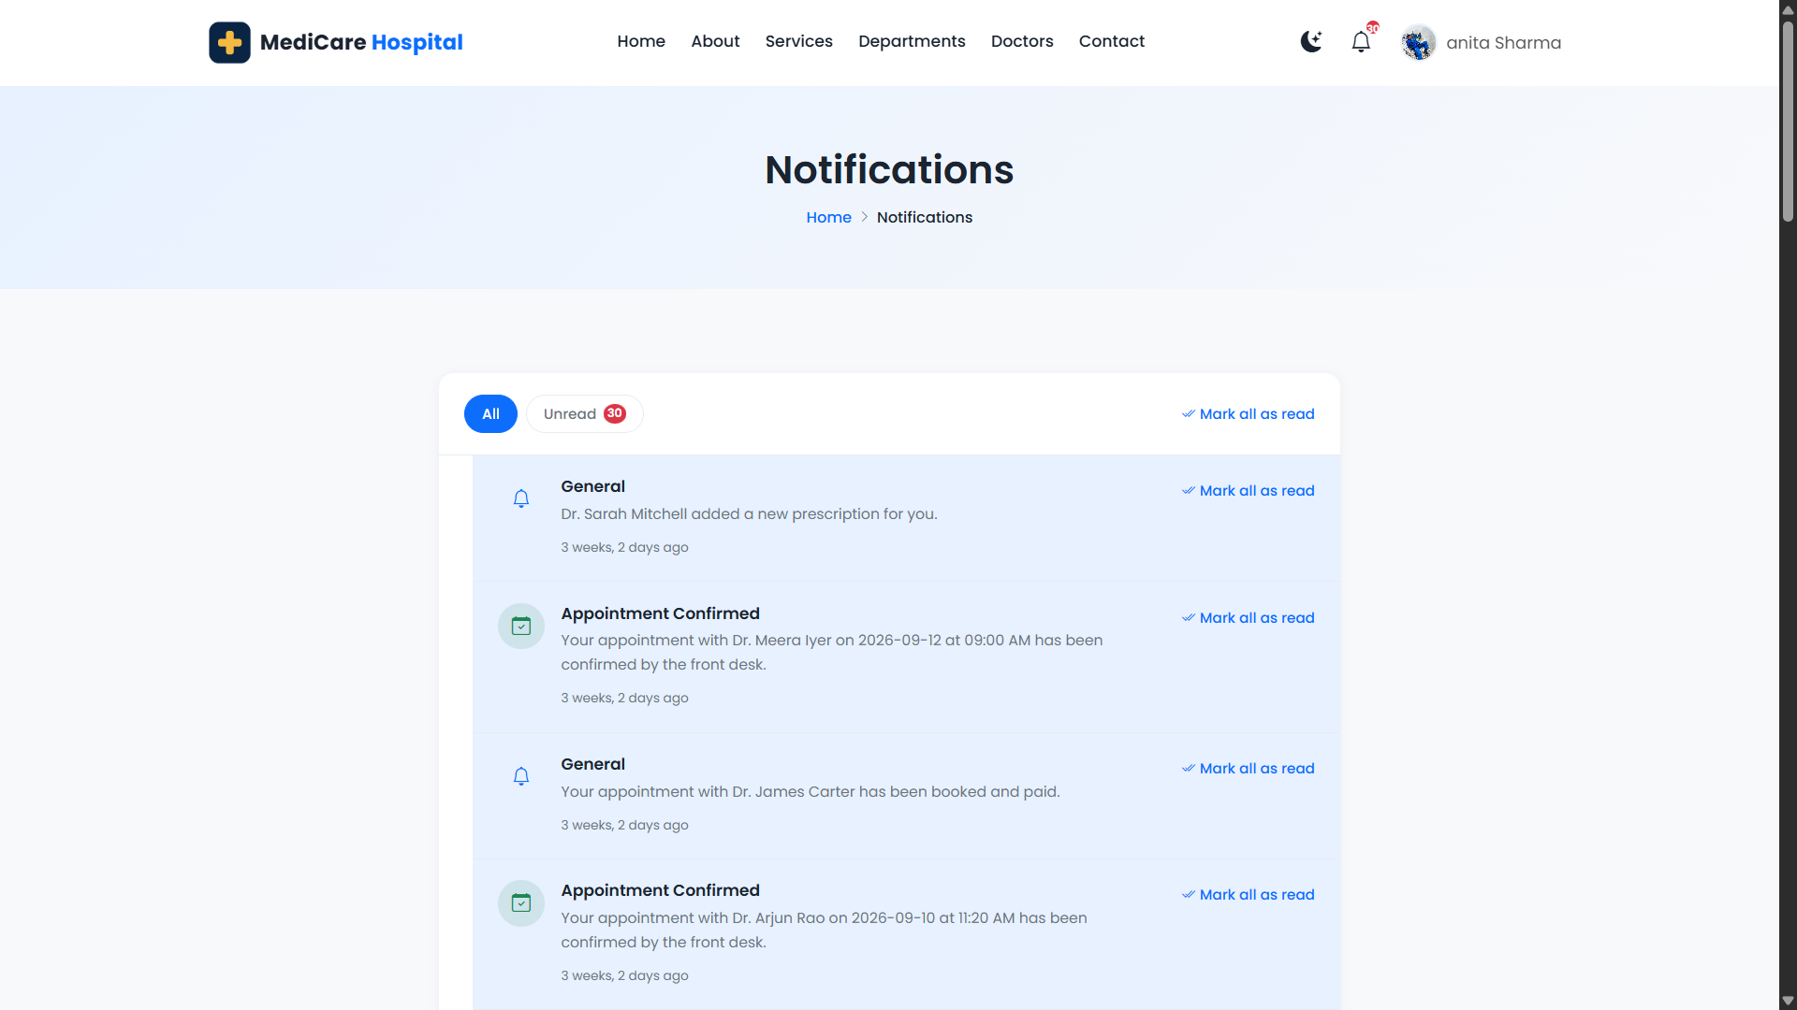Figure 18.26: Patient Notifications

18.6 RECEPTIONIST INTERFACE
The Receptionist Interface is designed to support the front-desk activities of the Hospital Management System.
Receptionists are provided with functionality for patient registration and management, appointment booking and management, doctor information, billing operations, notifications, and profile management.
Access to these functions is controlled according to the receptionist's role in the system.
18.6.1 Receptionist Dashboard
The Receptionist Dashboard serves as the main interface for front-desk operations.
It provides quick access to the important functions required by the receptionist and presents relevant hospital information in an organized dashboard layout.
The dashboard helps the receptionist efficiently access patient, appointment, doctor, and billing-related operations.

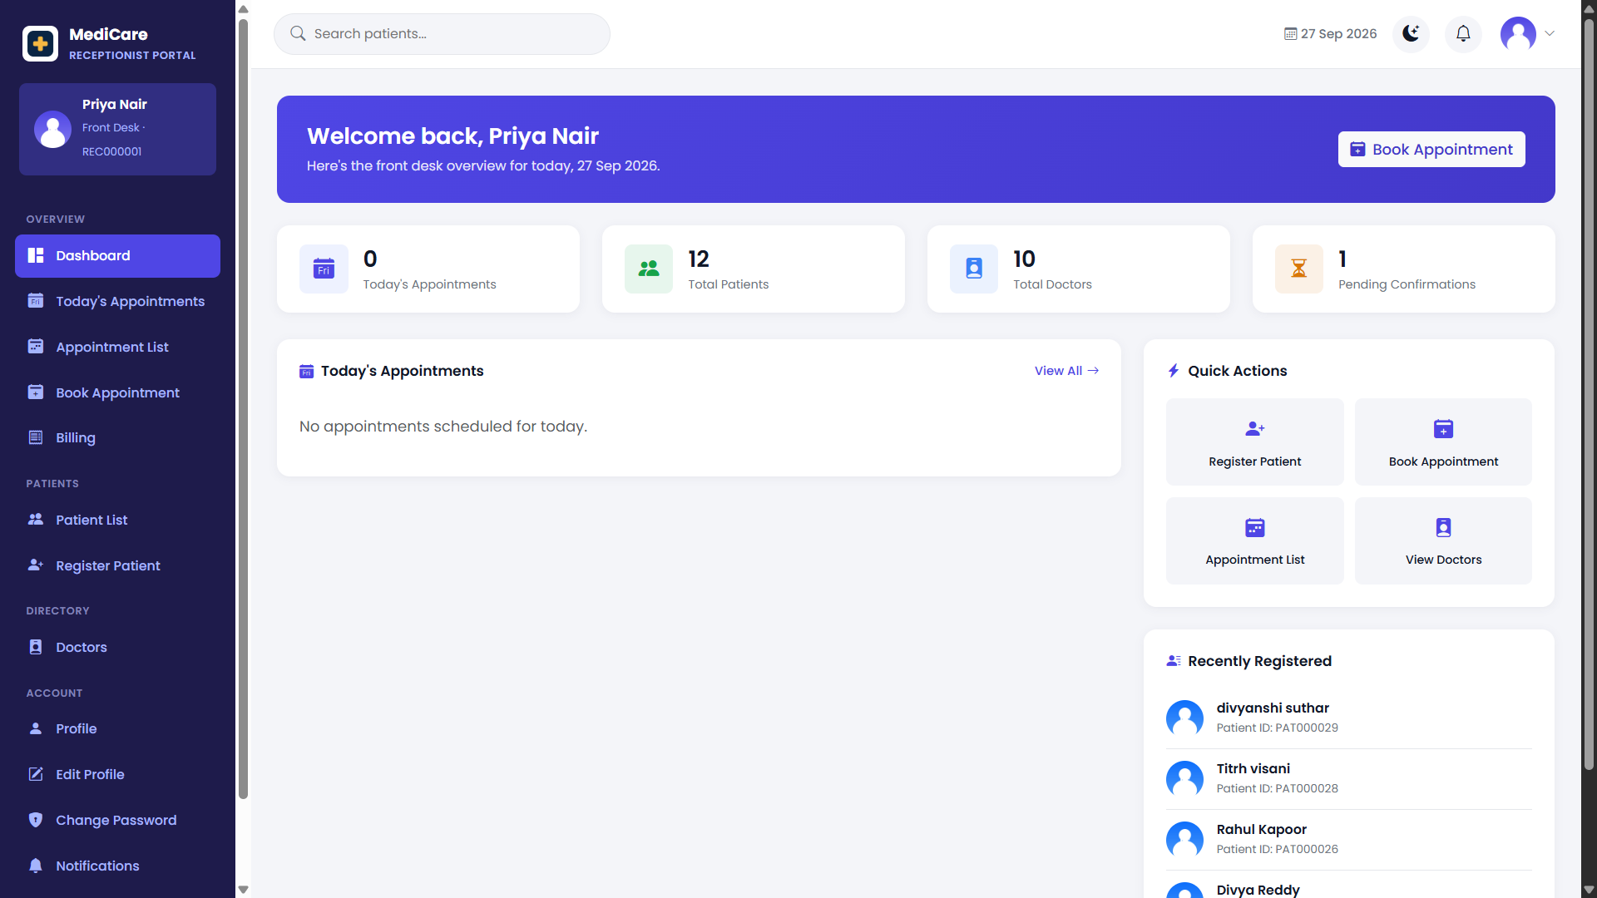Figure 18.27: Receptionist Dashboard

18.6.2 Patient Registration
The Patient Registration interface allows an authorized receptionist to register a new patient in the Hospital Management System.
The receptionist enters the required personal and contact information of the patient. After validation, the information is stored in the centralized hospital database.
This allows newly registered patients to be managed through the hospital system.

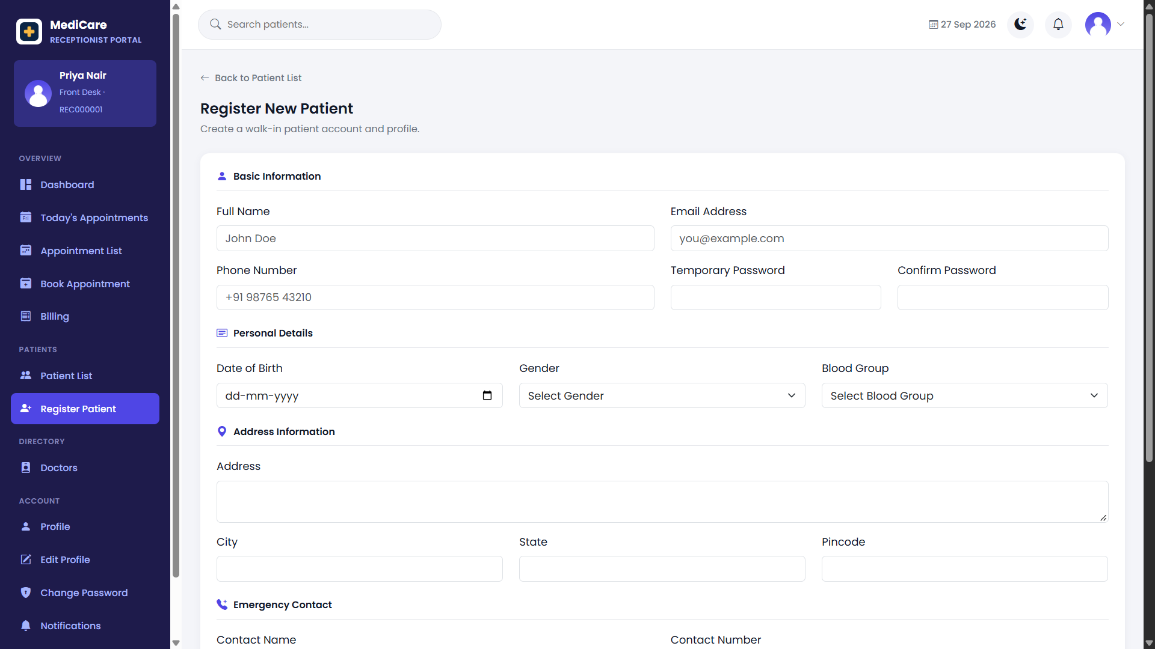Figure 18.28: Patient Registration Page

18.6.3 Patient Management
The Patient Management interface allows the receptionist to view and manage registered patients.
The receptionist can access the Patient List to locate existing patients and open the Patient Details interface to view the information available for a selected patient.
The current system provides separate patient list and patient detail interfaces for receptionist operations.

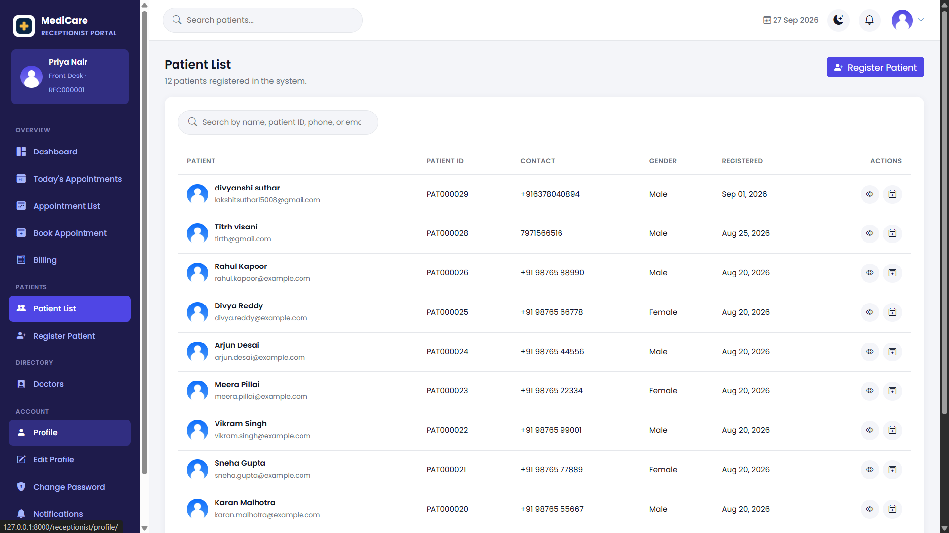Figure 18.29: Receptionist Patient Management

18.6.4 Receptionist Appointment Booking
The receptionist can schedule appointments for patients using the Appointment Booking interface.
This functionality is useful when a patient contacts or visits the hospital front desk and requires assistance scheduling an appointment.
The receptionist selects the required patient and doctor information and enters the necessary appointment details before submitting the appointment request.
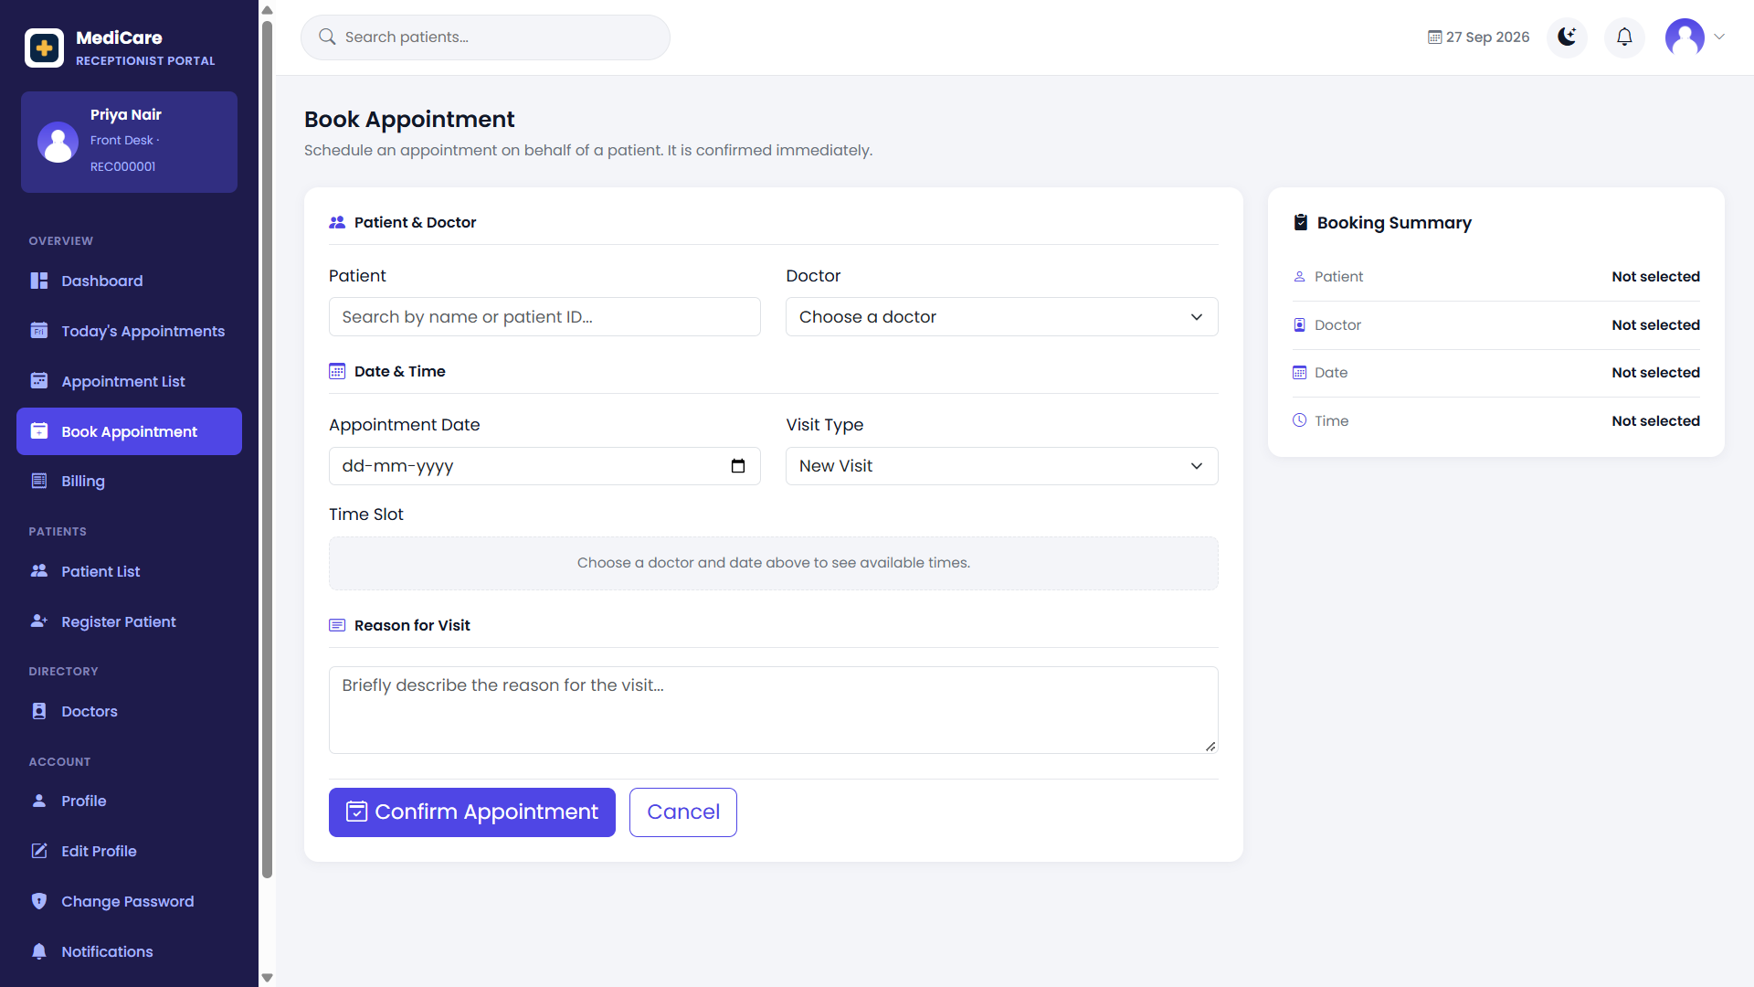Figure 18.30: Receptionist Appointment Booking

18.6.5 Appointment Management
The Appointment Management interface allows the receptionist to review appointments recorded in the Hospital Management System.
The appointment list presents relevant appointment information and provides the receptionist with access to the appointment operations permitted by the system.
A dedicated receptionist appointment list is implemented in the current project.
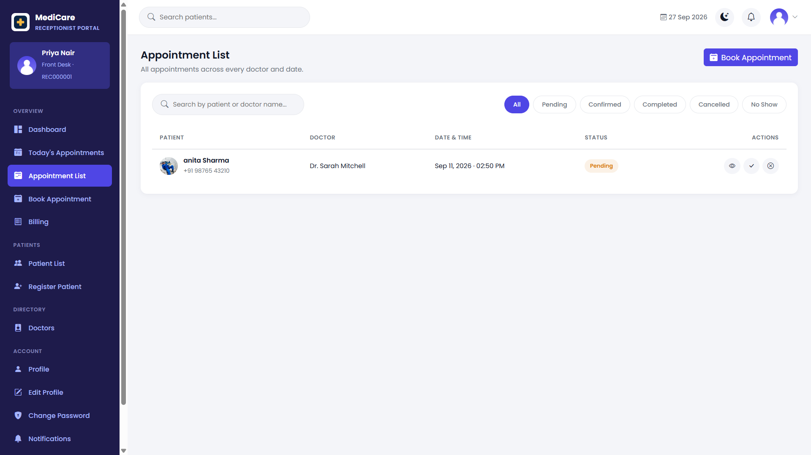Figure 18.31: Receptionist Appointment Management

18.6.6 Doctor List
The Doctor List interface allows the receptionist to view doctors available in the Hospital Management System.
Doctor information can assist the receptionist when handling appointment requests and identifying an appropriate doctor for a patient.
The current receptionist interface contains a dedicated Doctor List page.
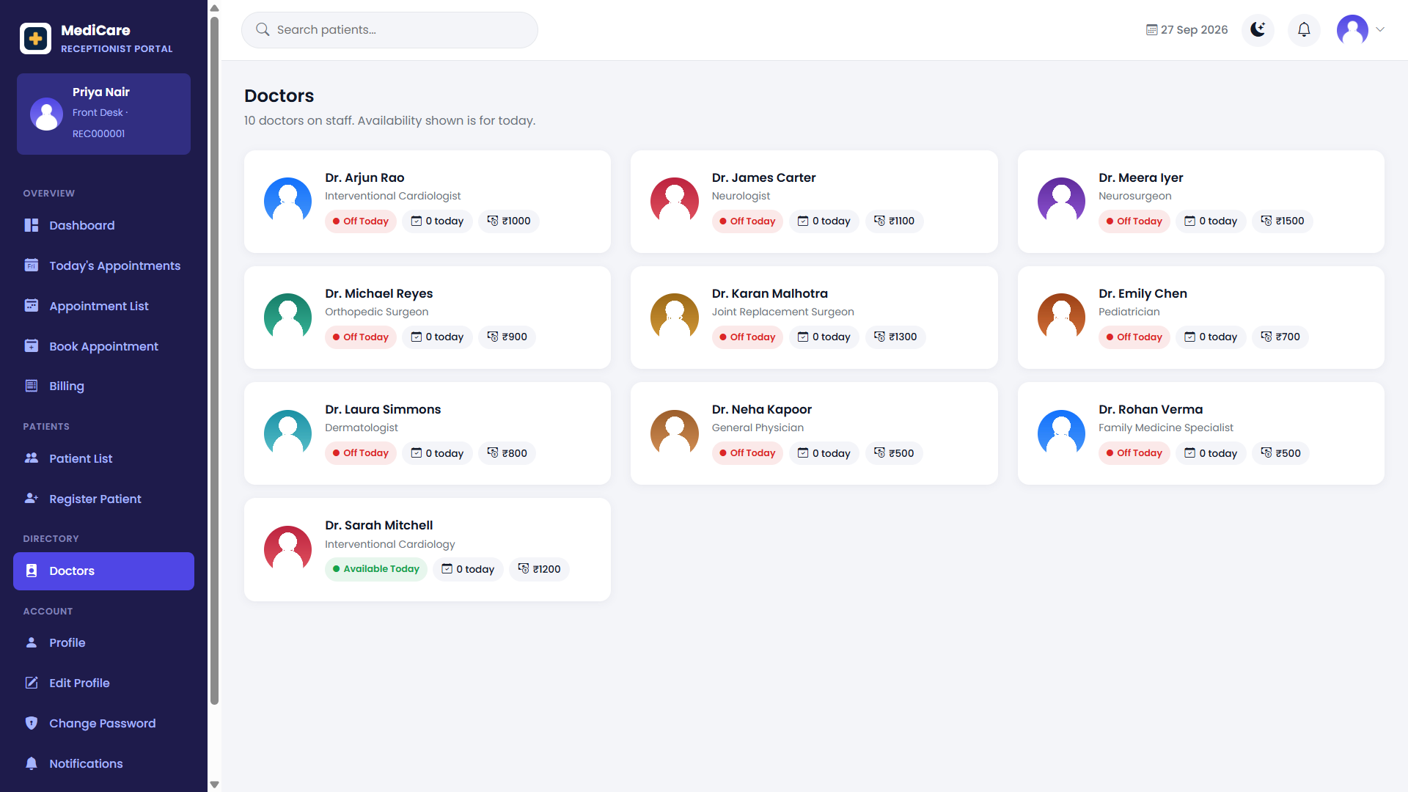Figure 18.32: Receptionist Doctor List

18.6.7 Receptionist Billing
The Receptionist Billing interface provides access to billing information associated with hospital appointments.
The receptionist can review billing records and access permitted billing-related operations. The system also provides billing receipt functionality for available billing records.
The current project contains dedicated receptionist billing list and billing receipt interfaces.
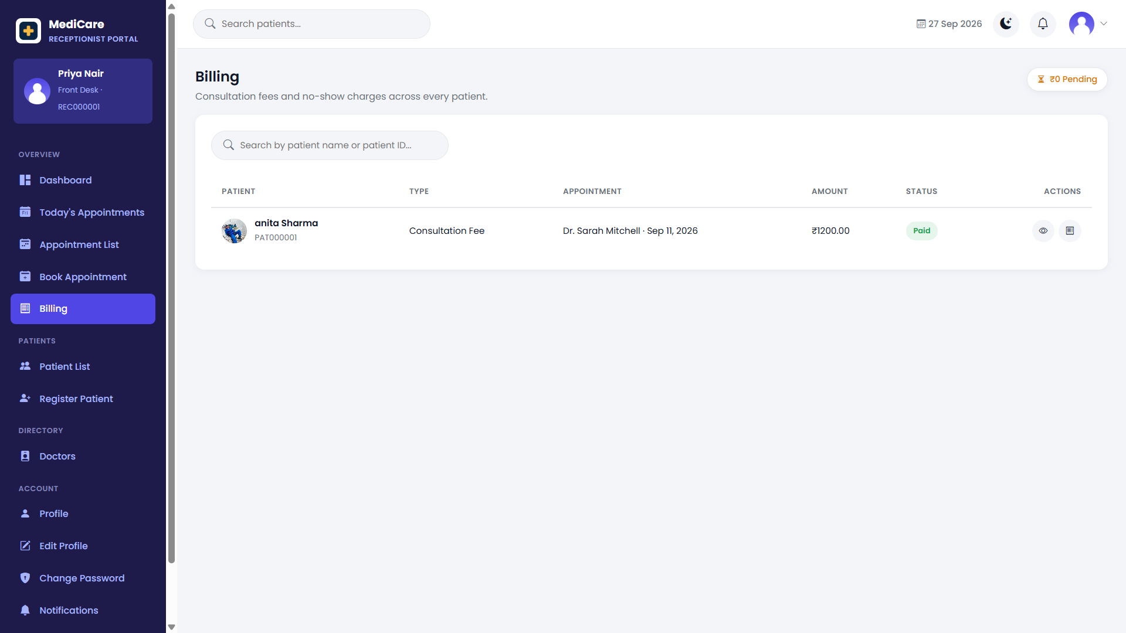Figure 18.33: Receptionist Billing Management

18.6.8 Receptionist Notifications
The Receptionist Notifications interface displays notifications relevant to receptionist activities within the Hospital Management System.
It provides a centralized location where the receptionist can review available system notifications.
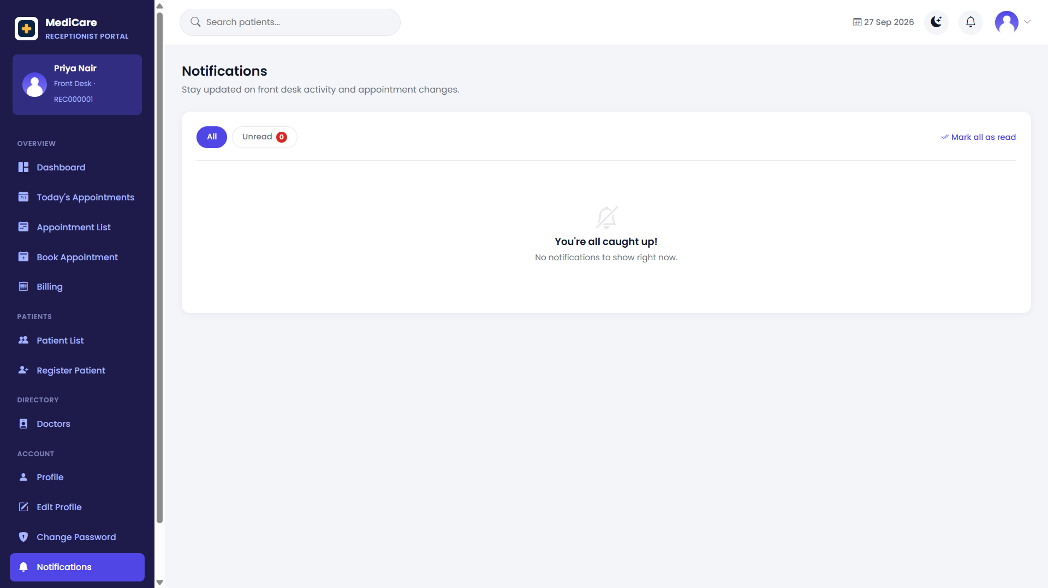Figure 18.34: Receptionist Notifications

18.6.9 Receptionist Profile
The Receptionist Profile interface displays the account and profile information of the currently authenticated receptionist.
The receptionist can review profile information and access available profile management functionality. The receptionist module also contains profile editing and password-change functionality.
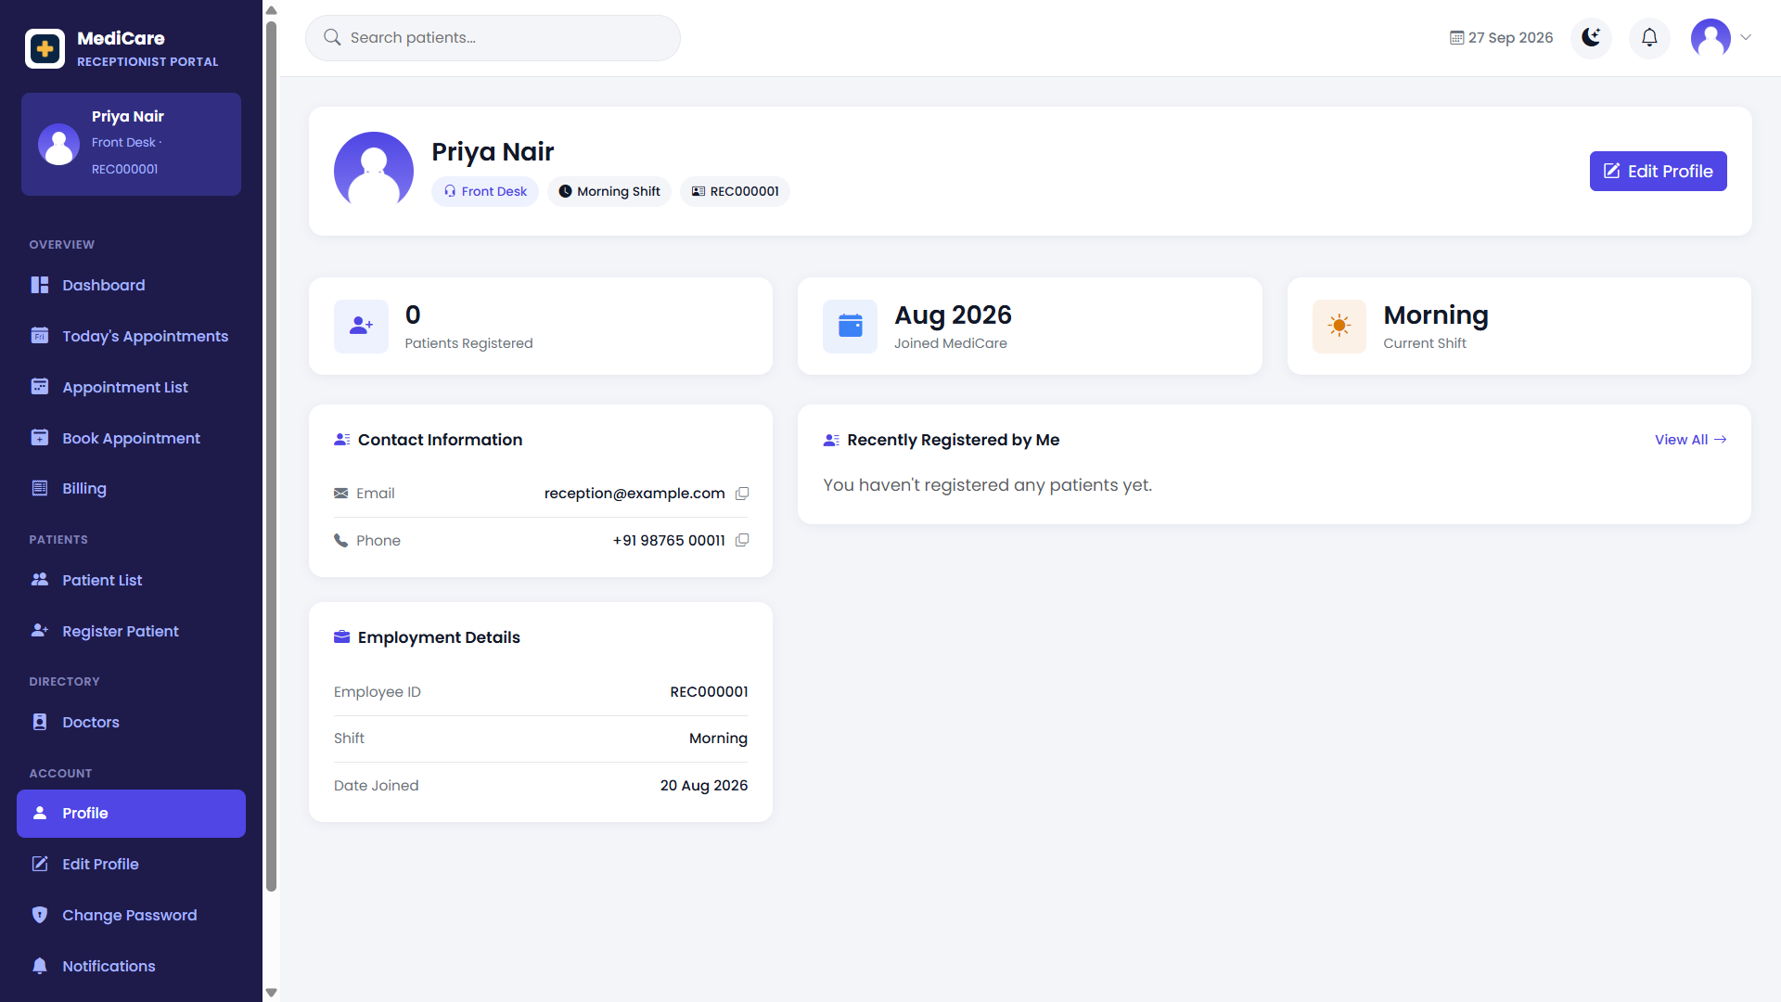Figure 18.35: Receptionist Profile Page

18.7 CONTACT PAGE
The Contact Page provides an interface through which users can communicate with the hospital.
Users can enter the required contact information and submit a message through the contact form.
The Contact Page provides a simple and organized method for users to send general inquiries or messages to the hospital.

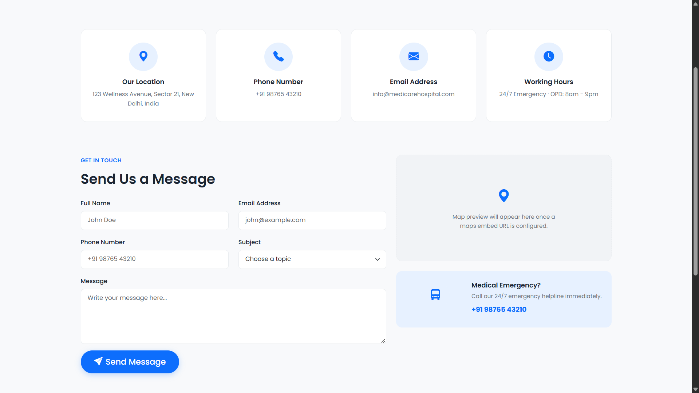Figure 18.36: Hospital Contact Page

18.8 RESPONSIVE USER INTERFACE
The Hospital Management System uses a responsive web-based user interface designed for modern web browsers.
The interface uses Bootstrap and project-specific CSS to organize pages across different screen sizes. Important user interface components such as navigation elements, forms, cards, tables, dashboards, and buttons are designed to remain organized and usable on supported screen sizes.
Responsive design improves the usability of the Hospital Management System on desktop and smaller displays.
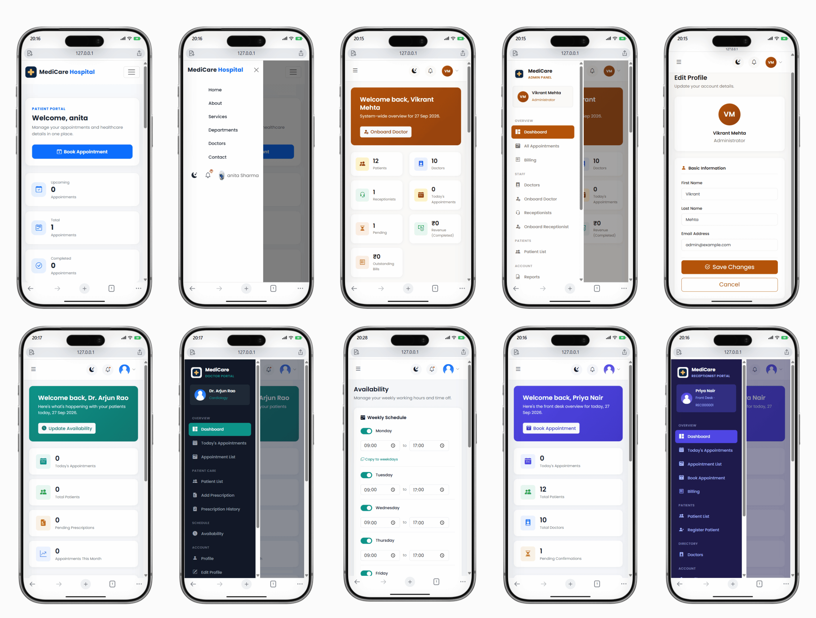
Figure 18.37: Responsive Hospital Management System Interface

18.9 UI DESIGN SUMMARY
The Hospital Management System provides separate role-based interfaces for the Administrator, Doctor, Patient, and Receptionist. Each authenticated user is provided with functionality according to the responsibilities and permissions of their role.
The Administrator Interface provides access to administrative and management operations of the system.
The Doctor Interface provides functionality related to appointments, patients, prescriptions, availability, and doctor account management.
The Patient Interface provides access to the Patient Dashboard, patient profile, doctor information, appointment booking, appointment history, billing information, and notifications.
The Receptionist Interface supports front-desk activities such as patient registration and management, appointment booking and management, doctor information, billing operations, notifications, and receptionist profile management.
The overall user interface focuses on simple navigation, structured forms, readable tables, dashboard-based access, responsive design, and role-based functionality.
These interfaces allow users to perform common hospital operations efficiently while ensuring that each user role accesses the functions relevant to its responsibilities.

